Western States Clan MacLaren Society, Inc.
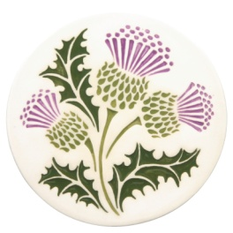 The Scottish Thistle Newsletter 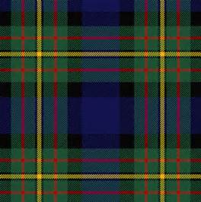
Fall 2017 Volume 2 Issue 4

WSCMS’s AGM held in Conjunction with Treasure Valley Celtic Festival on Friday, September 29, 2017
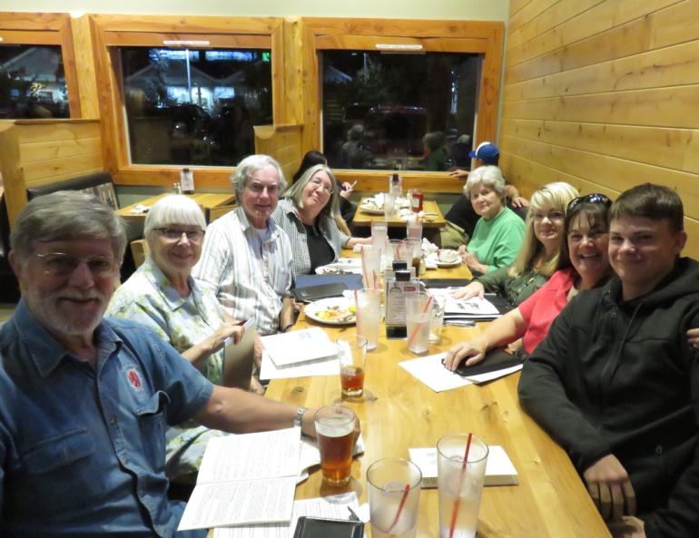
WSCMS Annual Meeting was held at the Sockeye Restaurant in Meridian, Idaho on Friday, September 29, 2017; L to R: Pete & Karen Woodall, Norm & Margaret English, Barbara Gard, Tracey Martin, Nina Garcia, Tracey’s son Chris Martin
In conjunction with the Treasure Valley Celtic Festival on Saturday, September 30, 2017, the Officers and Board Members of Western States Clan MacLaren Society held their 3rd Annual Meeting of the Society on Friday, September 29th at the Sockeye Restaurant in Meridian, Idaho. There were eight people present, seven members, and a full agenda was taken care of at the dinner meeting, including approval of last year’s minutes, Treasurer’s Report showing our current bank account balance of $464.09, Membership Report which showed we currently have 29 members, although three have not paid their dues for this year, Vice President Norm English reported that we’re about to prepare our 8th newsletter, and Webmistress Tracey Martin reported that we have an active website regularly updated with newsletters, photographs, and items of interest to members.
We had a really nice discussion about building our membership base, ‘Getting the Word Out’ about our Society, provided a listing of potential 2018 Scottish events that we will try to cover as we are able, held the election of Officers/Board Members for the next two year cycle, and all of the current ones agreed to continue for the next two years. In addition, it was noted that Penny McLaren will take over The Scottish Thistle newsletter, and Tim McLaren will take over the Membership duties, both beginning January 1. A decision to hold next year’s AGM at the inaugural McMinnville, Oregon Scottish Festival (formerly Newport, Oregon Celtic Festival & Games) on the second weekend of June, provided we can make it work for us. If it can’t be worked out, our AGM will be held at the Kelso, Washington Highland Festival in September, 2018. (continued on Page 2)
(Continued from Page 1)
Under New Business, the group decided to work towards giving a donation to some worthy cause, the specific one to be determined at the 2018 AGM. In addition, after much discussion, we agreed to make a revision to the membership section of our bylaws to broaden the base of possible members for our Society. You will be hearing more about this in the next couple of newsletters, with a membership vote on approval taking place at next year’s annual meeting. In conjunction with that vote, we are developing a Proxy form to send out to members, so that those unable to attend the AGM meetings will still be able to vote. All in all, we had a very productive meeting, and the minutes will be distributed to members soon.
Treasure Valley Celtic Festival on Saturday, September 30, 2017
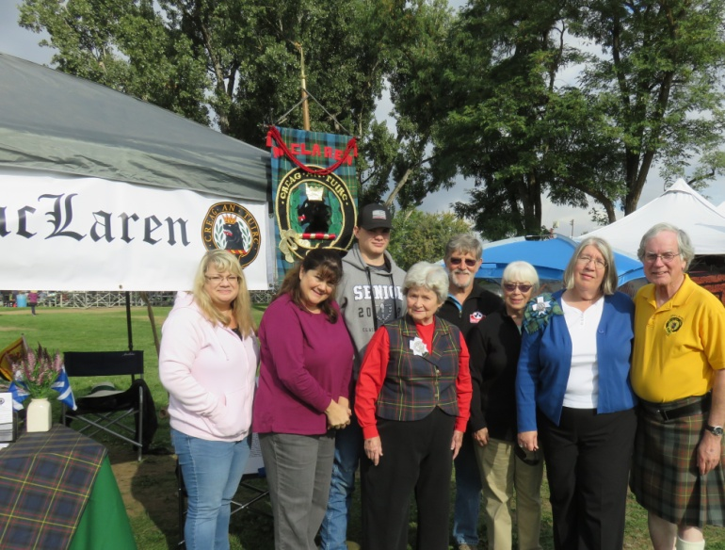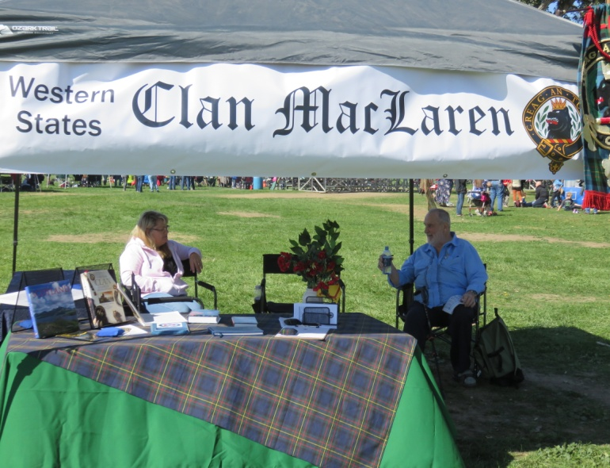
WSCMS Tent at the Treasure Valley Celtic Festival on Hosting the WSCMS Tent in Boise
Saturday, September 30, 2017; L to R: Tracey Martin, Tracey Martin (L), WSCMS Webmistress, and Bill
Nina Garcia, Chris Martin (Tracey’s son), Barbara Gard, McFadden from Seattle (R) man the tent for the clan
Pete & Karen Woodall, and Margaret & Norm English
The following day, WSCMS set up their tent at the Treasure Valley Celtic Festival on the Fairgrounds. Circling the central field, there were a number of clan tents, quite a number of vendors offering their wares to festival goers, pipe bands and dancers keeping the crowd entertained, and off to one side of the grounds were the athletic events, and in another corner were the food vendors. It was a lively event, and everyone seemed to enjoy themselves. Lots of families were there, with many opportunities to keep the kids occupied. Our tent had several visitors who stopped by to chat and to find out more about their Scottish connections. It was a great chance to connect with others as well as with each other. And the weather cooperated too, with plenty of sunshine, and the temperatures were comfortable throughout the day.
Message from the President

Hello WSCMS Family:
Thanks to everyone who attended our AGM in Boise. We established a quorum and took care of several points of business. One of the most important was officer elections. Since life intervened in just about everybody’s circumstances this past year, it was discussed and decided that current officers would all serve another two year term. Although all the officers, including myself, graciously agreed to a second term, please consider what role in our Society’s leadership you can perform. We are a small group and our leadership tasks are not overly grueling. But they do require a small investment in time and energy. If there is an office in which you are particularly interested, please contact me or the current office holder. We would like to give you the benefit of our experience, training if you will, to avoid a disjointed or disconnected transition next election. If you don’t reach out, I may ask Barbara to do some convincing!
A special thanks to Penny McLaren for agreeing to take on the responsibility of publishing our newsletter starting in January, and also to Tim McLaren who will work with the membership duties. Those roles are super important.
A second important point of discussion was our sense of social obligation, and we decided to do fundraising for a worthy cause next year. We will make fleece blankets and raffle them off, particularly at festivals and events. Since we have members currently serving in the U.S. Military and several members with prior military experience, ‘military themed’ fleece was decided upon. Barbara wanted to make the blankets and has obtained fleece for Army, Navy, Air Force and Marines. We are searching for the Coast Guard fleece.
So, with the blankets in mind, we are searching for good causes to which we can direct our fundraising. If you have suggestions, please don’t be shy about voicing them. We will have two sets of blankets, one for Boise and one for either Kelso or wherever we determine we will have our next AGM.
In the meantime, as we begin the slide into the holiday time of the year, have fun, stay safe, keep warm, and make merry! Hugs!! Nina
A Few Thoughts from Vice-President Norm English
As this issue of the newsletter is being written, WSCMS is beginning its third year of existence as a nonprofit Idaho organization. I thought I might retrace briefly how and why we got to this point:
A number of Clan MacLaren Society of NA members, particularly from Idaho, but also from the Northwestern United States and Canada, having a strong desire to hold an Annual General Meeting (AGM) of that Society, organized an effort to host such a meeting in 2017 in Boise in conjunction with the Treasure Valley Scottish Festival. They contacted the Mayor of Boise, Governor of the State of Idaho, and a number of area businesses, and ultimately assembled a written proposal which was presented to the CMSNA Council at their 2015 meeting in Michigan. Another site ultimately was chosen for the AGM. Soon thereafter, a group of Western Region Clan MacLaren members decided that it would be beneficial to form a new Society that emphasized their geographical location, hence the name Western States Clan MacLaren Society, Inc. The stated purposes of our Society are the following: ‘to foster and encourage interest in the history, culture, and traditions of Scotland in general, and Clan MacLaren in particular, as well as in providing information and education regarding the same, and to promote collegiality and friendship among members’. This Society includes all U.S. states and Canadian provinces either West of the Continental Divide or intersected by it, including Montana, Wyoming, Colorado, New Mexico, Arizona, Utah, Nevada, Idaho, Washington, Oregon, California, Alaska, Hawaii and British Columbia and Alberta. At this point in our existence, we have members in eight states and British Columbia.
Our Society operates under a few basic premises including the following: a) to celebrate our Scottish heritage and our MacLaren family history, b) to enjoy each other in our associations with one another, and c) to promote a ‘less formal’ atmosphere in our meetings, discussions, and festival/games activities. In addition, our Society respresents only our family name, MacLaren, at Scottish events that we attend. Cheers!
Norm
Coming Events in 2018
4th Saturday in May = Eugene, OR Scottish Festival
2nd Weekend in June (Pending) = McMinnville, OR Celtic Festival/Games
3rd Weekend in July – Portland, OR Highland Games
1st Weekend in August = Spokane, WA Highland Games
3rd Weekend in August – Winston, OR Celtic Highland Games & Clan Gathering
2nd Weekend in September – Kelso, WA Highlander Festival
4th Saturday in September = Boise, ID Treasure Valley Celtic Festival
1st Weekend in October = Eugene, OR = McKenzie Highland Games

Remember to check out our website:
http://westerstatesmaclaren.weebly.com/
WSCMS Membership as of October 1, 2017
AZ WA OR ID CO CA MT WY B.C. Total
2 4 6 6 2 4 1 2 2 29 17January
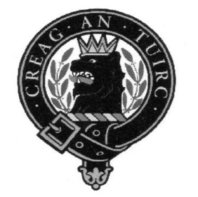
Western States Clan MacLaren Society, Inc.
Officers/Board Members through December 31, 2019

President Vice-President/Newsletter Editor Secretary
Nina Garcia Norm English Karen Woodall
nina.clanmaclaren@gmail.com (503) 874-8101 (360) 576-4969
normengl@msn.com starcars8@comcast.net

Treasurer
Tom Martin
(208) 764-2882
motor1137@yahoo.com

Board Members
Barbara Allen Gard Margaret English Pete Woodall
(971) 599-5759 (503) 874-8101 (360) 576-4969
barbgard07@gmail.com mdeng59@live.com starcars8@comcast.net

Tim McLaren
(360) 546-2271 drtmclaren@msn.com

Webmistress Newsletter Editor (January 1, 2018) Membership (January 1, 2018)
Tracey Martin Penny McLaren Tim McLaren
(208) 764-2882 (360) 546 2271 (360) 546 2271
tntawards@earthlink.net ampmcomm@msn.com drtmclaren@msn.com
Western States Clan MacLaren Society, Inc.
WSCMS, Inc. is a duly registered non-stock, non-profit organization
incorporated in 2015 under the laws of the State of Idaho
The Scottish Thistle Newsletter is a quarterly publication printed
expressly for WSCMS members

The deadline for the next issue of The Scottish Thistle is January 1, 2018

