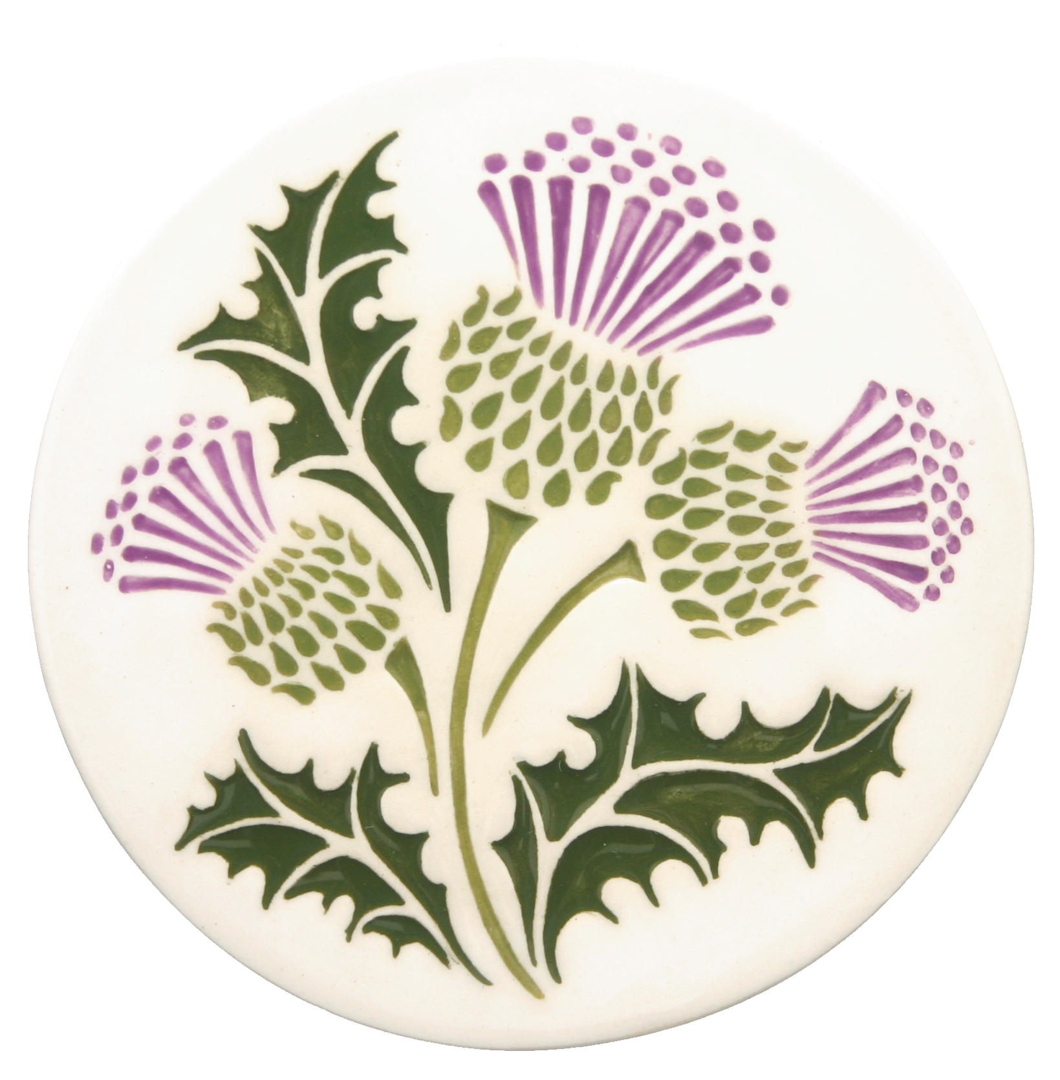 The Scottish Thistle Newsletter 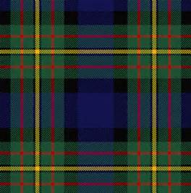
Fall 2016 Volume 1 Issue 4

Scottish Events Reports

Kelso Highlander Festival – September 10-11, 2016
WSCMS Annual Meeting
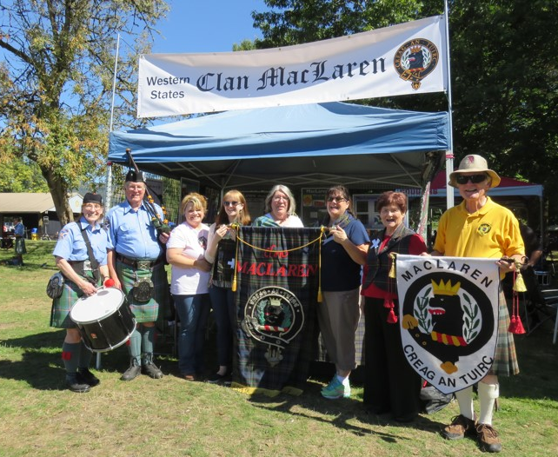
WSCMS members (L to R): Penny McLaren, Tim McLaren, Tracey Martin, Robyn Miller, Margaret English, Nina Garcia, Barbara Gard, Norm English (Not pictured are Pete & Karen Woodall)

The WSCMS’s annual meeting took place in the tent at the Kelso Highlander Festival on September 10, 2016, with 10 members present. Our tent was located within view of the athletic competitions, where three MacLaren athletes were among those competing. Our meeting was very productive, deciding to alternate our annual meetings between Kelso and Boise, so next year’s meeting will be at the Treasure Valley Celtic Festival in Boise, at which time we will elect officers and appoint board members. We had a nice little gathering of members. The Kelso Festival is a nice family-oriented event, with entertainment in the pavilion, which included the Wicked Tinkers this year, and an assortment of food and other venders, and activities for the kids. Clan organizations were well represented along ‘clan row’, and there was a nice opening ceremony on Saturday which WSCMS members marched in. We were also able to sell a number of dulcimer raffle tickets. The weather was beautiful, the crowds enjoyed themselves, and we had a number of visitors to the tent.

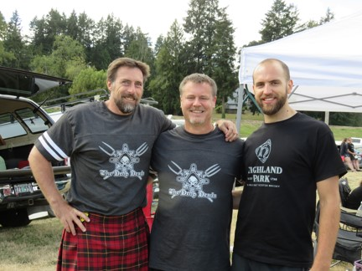
WSCMS members Kevin Halsey, Ray Mabey & Nigel Anselmi all competed at the Kelso – September 10-11, 2016

Treasure Valley Celtic Festival – September 24, 2016

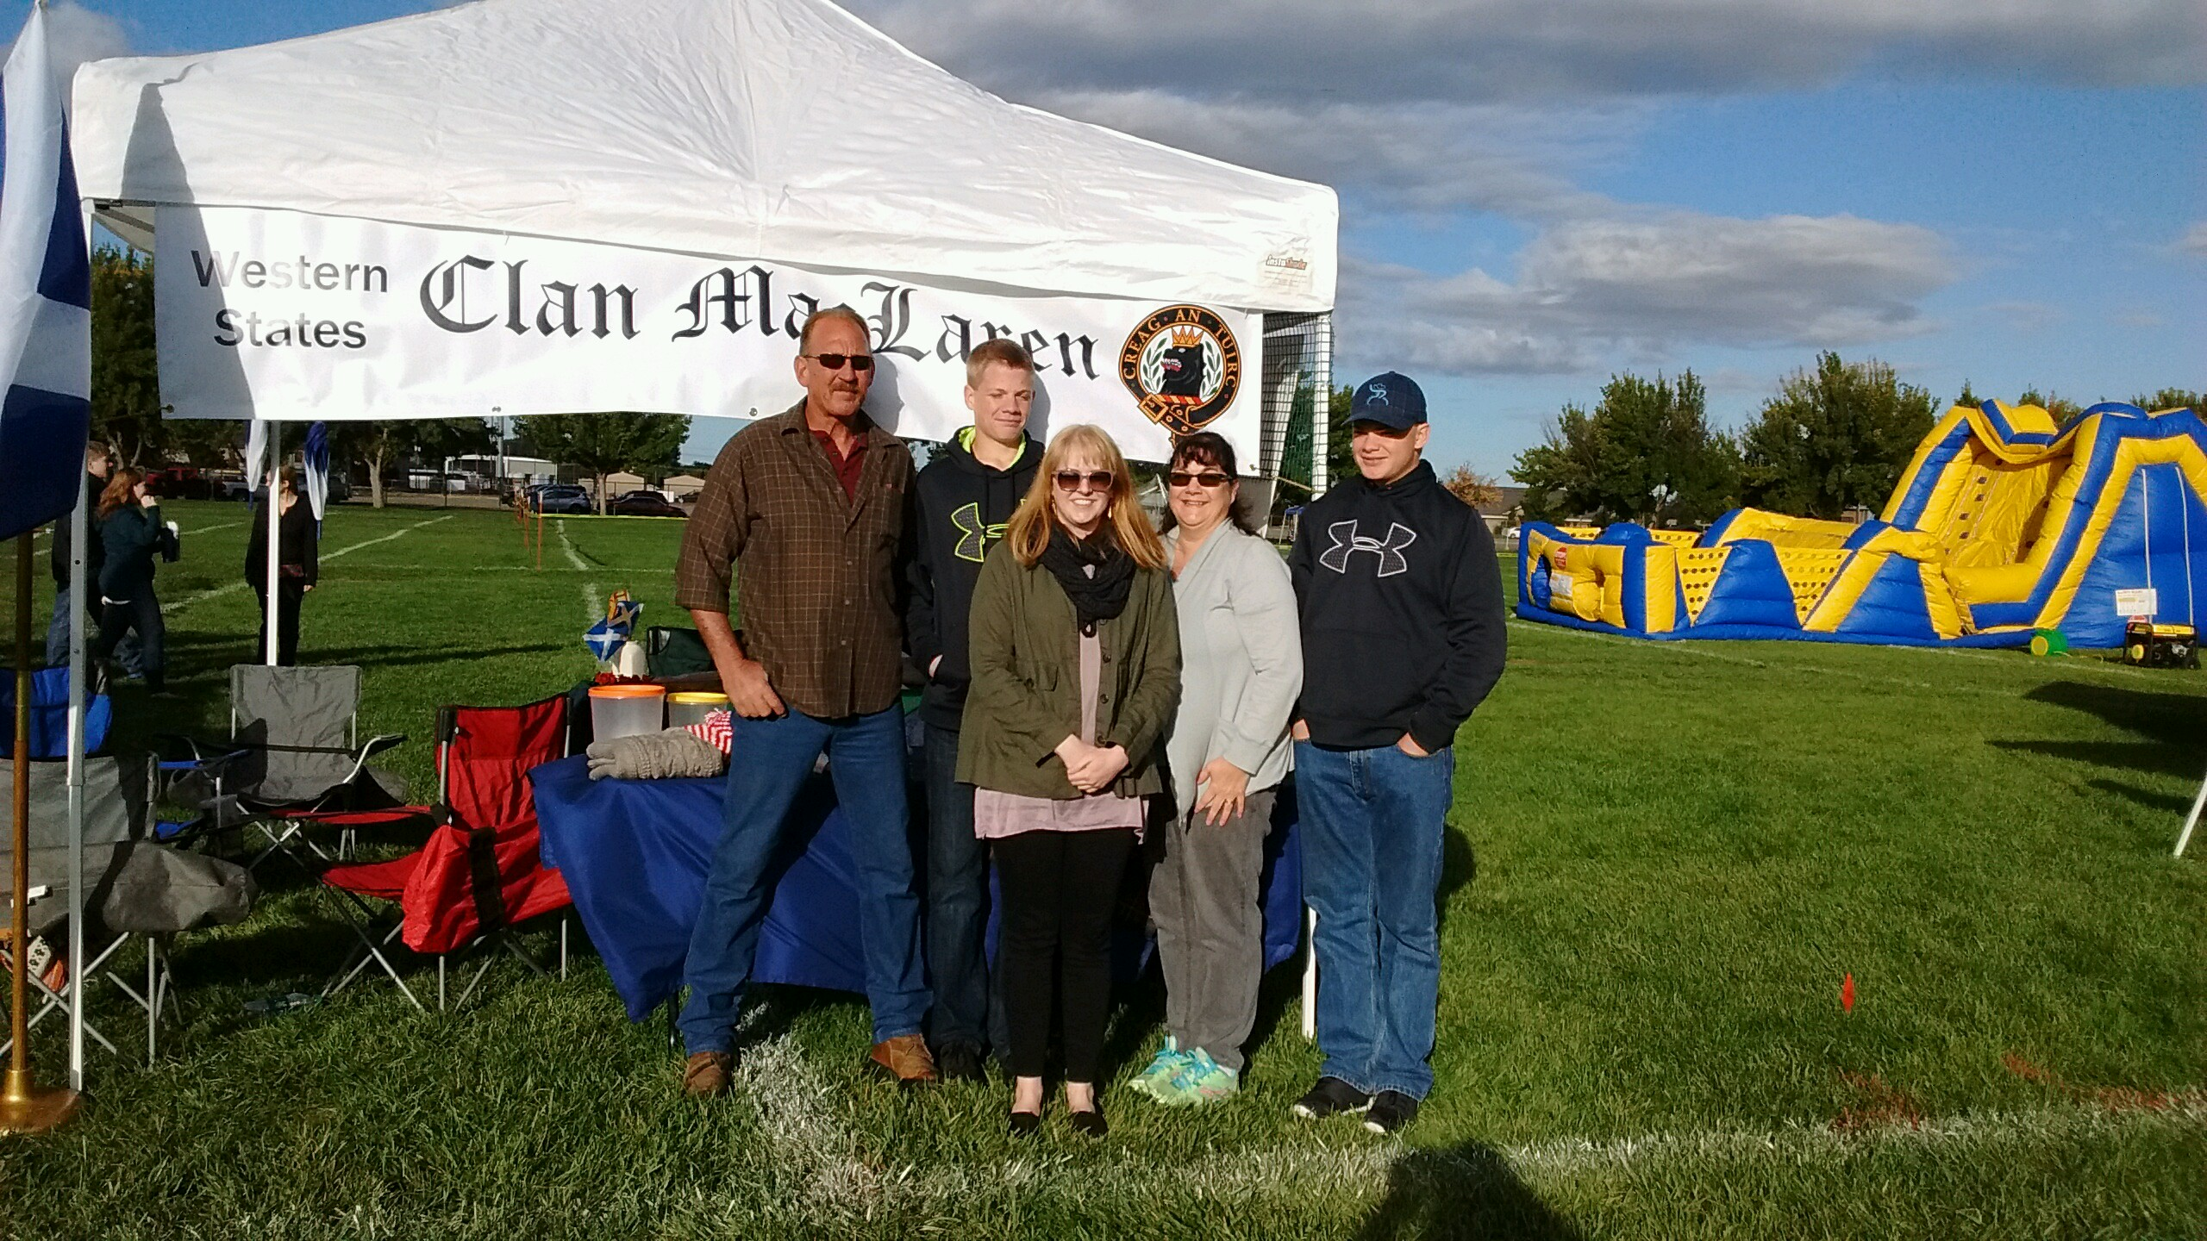
WSCMS members in front of the clan tent at the Treasure Valley Games – September 24, 2016

The Treasure Valley Celtic Festival, also known as the Boise Games, was wonderful as expected. The weather was a little colder to start this year, but it only gave us excuses to buy things to keep us warm! This year, our tent was located right next to the children’s bounce house. The playing kiddies didn’t pose any problem at all, but the noise from the generator prevented us from hearing the MC, the softer pipe notes, and some conversations at the
tent were just impossible. We gave our concerns to the games organizers and they will make every effort to locate the bounce house further away from the clan tents next year. The games were very well attended this year. They ran out of tickets and programs, which is a good thing; it means our little venue is growing.

We had one very satisfying moment when a lady came by the tent and shared that she had no family living and was upset because she knew her heritage was Scottish, but could not find a clan. Her family name was Aitchison.

We looked her up in our clan name book, and she was thrilled to discover she was a Gordon. She left with a renewed sense of belonging and promised to drop by our tent next year and tell us about her research into her new – old family.

We were wonderfully entertained by our member Bob Sewell on the dulcimer that he had graciously donated to WSCMS. The bounce house prevented us from completely enjoying his playing, but what we could hear was wonderful. We’re hoping to cajole him into bringing his dulcimer and playing for us again next year. We had several persons come by who were sorry they had missed hearing him play. The winner of the dulcimer, drawn by a member of Clan MacLachlan, was Jane Wille of Salem, Oregon.

Again this year, hand-knit goods were donated by WSCMS member Jean Christodoulou. We had an adult sweater and a scarf, both in the Arran style, but made with modern, easier to care-for yarn. She also donated a child’s holiday sweater and hat. The winner of the adult sweater was Anita Lawrie of Boise. The scarf went to Robert Bunch. The child’s items did not have a taker, but we’ll see what holiday event might bring us luck.
Everyone had a wonderful time, and we look forward to seeing everyone next year.

Dulcimer Raffle – “And the winner is…..”

Jane Wille – Salem, Oregon

Message from President – Nina Garcia

Our first full year of activities is almost over, and we have been busy. Our Western States MacLaren’s have been involved in Burn’s Suppers, Saint Andrew’s Dinners, simple get togethers, musical and athletic events, and of course our tents. We have all had a wonderful time celebrating with each other and enjoying all things Scottish. Everyone pitched in and contributed what they could to make our first year a rousing success. I would like to thank Bob Sewell for his very generous donation of the highland dulcimer and Jean Christodoulou for the wonderful hand-knit sweaters. Without these items to raffle off, our purse would be completely empty.
Sometime soon, membership dues letters will be sent – via email or snail mail. Please watch for them. Our dues are not high, but every penny we have helps, so get them sent back as soon as you can. Currently, any expenses we incur are being met by individual members, and it would be nice to offset administrative costs a little.
I would also like to offer our collective congratulations to member Nick Martin on his successful graduation from the Navy’s (Medical) Corpsman School. (I am sure I said that all wrong). Anyway, his next stop involves training with the Marine Corps. And also congratulations to member Robyn Miller, who is off to Navy basic training. We are very proud of our younger members for several reasons, including their interest in keeping our historical heritage alive, and of course for their selfless service to our country. You make us all look good.
So, all in all – a very good year MacLarens – way to go!
Coming Events in 2017
4th Saturday in May - Eugene, OR Scottish Festival
3rd Saturday in June – Prosser, WA Scottish Festival & Highland Games
3rd Weekend in July – Portland, OR Highland Games
3rd Weekend in August – Winston, OR Celtic Highland Games & Clan Gathering
2nd Weekend in September – Kelso, WA Highlander Festival

**SAVE THE DATE**
September 23, 2017
WSCMS Annual Meeting
Boise, Idaho - Treasure Valley Celtic Festival

Check out our website:
http://westerstatesmaclaren.weebly.com/
WSCMS Membership as of October 1, 2016
Washington Oregon Idaho California Montana B.C. Total
4 6 8 3 1 2 24

Welcome New Members!
Tom Martin (August, 2016)
Kevin P. Halsey (September, 2016)
Raymond G. Mabey (September, 2016)
Remember Members: Dues Notices will go out in December

The deadline for the next issue of The Scottish Thistle is January 3, 201717January

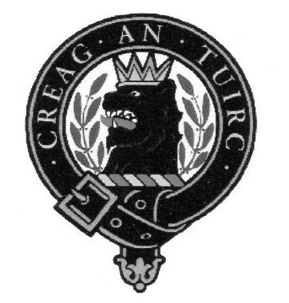

Western States Clan MacLaren Society, Inc.
2016-2017 Officers/Board Members

President Vice-President Secretary
Nina Garcia Norm English Karen Woodall
nina.clanmaclaren@gmail.com (503) 874-8101 (360) 576-4969
normengl@msn.com starcars8@comcast.net

Board Members
Barbara Allen Gard Margaret English Pete Woodall
(971) 599-5759 (503) 874-8101 (360) 576-4969
barbara.allen.gard@gmail.com mdeng59@live.com starcars8@comcast.net

Tim McLaren
(360) 546-2271 drtmclaren@msn.com

Webmistress
Tracey Martin
tntawards@earthlink.net
Western States Clan MacLaren Society, Inc.
WSCMS, Inc. is a duly registered non-stock, non-profit organization incorporated in 2015 under the laws of the State of Idaho
The Scottish Thistle Newsletter is a quarterly publication printed expressly for WSCMS members

