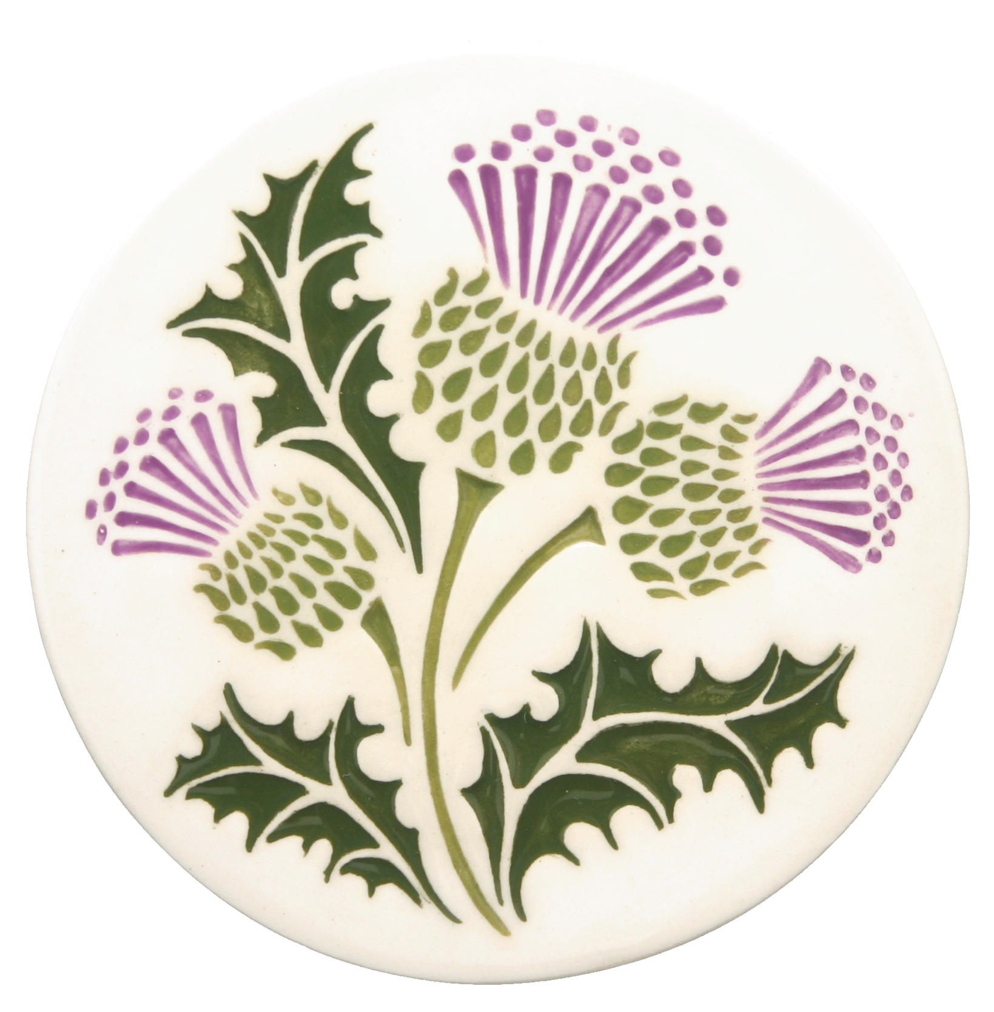 The Scottish Thistle Newsletter
Summer 2017 Volume 2 Issue 3

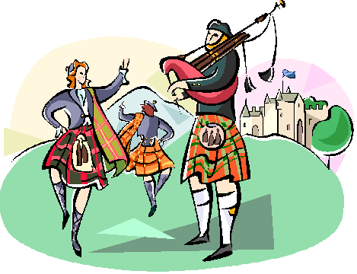
WSCMS Annual Meeting
September 30, 2017
Election of Officers/Board Members
Treasure Valley Celtic Festival – Boise, Idaho
Message from the President

Hello WSCMS Members:
The end of my inaugural tenure as president of our clan group, Western States Clan MacLaren Society, is at hand. It was quite an undertaking, and I had no idea what I was doing. But, as we steered our metaphoric ship through the proverbial storm, your suggestions and advice were invaluable. It was such a pleasure to work with a group of individuals for whom there were no secret agendas or daily doses of drama. We are truly blessed, and I am honored you trusted me enough to believe we could pull off our coup. We will hold nominations and elections for new officers at our annual meeting, which will be on September 30 of this year in Boise.
Now, I know this year has presented personal challenges to some of us. For some it has been health issues, for others it was financial, and for still others it was both. Others have been bombarded with drama not of their making. Please know that all of you are precious to me and are in my thoughts. I have been sending positive energy out into the cosmos to such an extent that I expect a call from NASA any day now telling me to stop.

Some of you have already shared that you will not be able to make the trip to Idaho this year. I completely understand. Please do not harbor any self-reproach for conflicting engagements or more pressing concerns. Life happens, and we don’t mind adjusting --- you will be missed, but you will not be excluded. We have phones, emails, and Skype --- we will get business done, and you will get updates.
Hugs and love to you all. You’re the best family a person could ask for. – Nina
A Few Thoughts from the Vice-President
We will soon reach the end of our first two-year cycle, and as Nina has indicated, there will be an election of officers for the next two years, with their terms starting on January 1, 2018. I certainly hope that all of you will consider being a part of the WSCMS Board in one of the available positions. These past two years have been a tremendous example of what can happen when an idea surfaces for a local group of like-minded individuals to form a group that celebrates their Scottish heritage.
We may be small in numbers, but we continue to be mighty in our efforts to ‘foster and encourage interest in the history, culture, and traditions of Scotland in general and Clan MacLaren in particular, as well as in providing information and education regarding the same, and to promote collegiality and friendship among members’. This is our stated purpose as noted in the words of Article 1 of our by-laws adopted back in the beginning when WSCMS was formed in Boise on September 26, 2015. A major part of all this is remembering to treat each other with dignity and respect as we move forward. We’re all in this together and that is part of what makes us strong. It is also extremely important to maintain a regular line of open communication with each other, and the quarterly newsletter, The Scottish Thistle, and our society’s website help to do just that.
It also remains important for others to be aware of what we have to offer, and that happens more readily when we tell everyone about WSCMS who indicates an interest in their Scottish heritage. Unfortunately over the past year or so, there have been at least a couple of Scottish festivals and games that have disbanded, but perhaps you or someone you know is aware of other events that can take their place. If so, please let one of us know about them and perhaps find out some details about those events and maybe even check them out for yourself.
We have a really good thing going, so let’s do all we can to enliven and enlarge our group so that others can join in the fun. I was recently asked if I might consider being President of this organization for the next couple of years. Unfortunately, due to recent health issues in my family, I will not be able to commit to that challenge, but certainly would consider continuing on as Vice-President for another term, if that is what the members decide. Or, if someone feels particularly keen on taking care of those duties in my stead, I would be okay with that as well. At any rate, I have enjoyed my two-year stint as Vice-President and as Newsletter Editor. - Norm
Other Coming Events in 2017
3rd Weekend in July – Portland, OR Highland Games
3rd Weekend in August – Winston, OR Celtic Highland Games & Clan Gathering
2nd Weekend in September – Kelso, WA Highlander Festival

Remember to check out our website:
http://westerstatesmaclaren.weebly.com/

WSCMS Membership as of July 1, 2017
Wa Or Id Co Ca Mt Wy B.C. Total
4 7 7 2 4 1 2 2 29
Note to WSCMS Members
If you have not yet paid your 2017 dues payment of $10.00, you may send it to: Tom Martin – WSCMS Treasurer, 296 E 400 S, Fairfield, ID 83327 17January

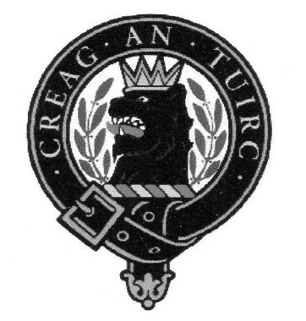 Western States Clan MacLaren Society, Inc.
Officers/Board Members through December 31, 2017

President Vice-President/Newsletter Editor Secretary
Nina Garcia Norm English Karen Woodall
nina.clanmaclaren@gmail.com (503) 874-8101 (360) 576-4969
normengl@msn.com starcars8@comcast.net

Treasurer
Tom Martin
(208) 764-2882
motor1137@yahoo.com

Board Members
Barbara Allen Gard Margaret English Pete Woodall
(971) 599-5759 (503) 874-8101 (360) 576-4969
barbgard07@gmail.com mdeng59@live.com starcars8@comcast.net

Tim McLaren
(360) 546-2271 drtmclaren@msn.com

Webmistress
Tracey Martin
(208) 764-2882
tntawards@earthlink.net

A Wee Bit of Highlander History
As far back as the 12th century, families in Scotland were organized into clans; most clans had a chief, and families paid homage to their leader, living off his land and paying rent in return for protection and alliance. Families often took on the name of their clan chief as a symbol of their loyalty.
Between 1688 and 1746, a number of uprisings occurred in an effort to overthrow the Hanoverian royal line in favor of a Stuart king. Supporters of these rebellions were called Jacobites, after Jacobus, the Latin form of James, a popular name in the House of Stuart.
The final uprising, the ’45, culminated in the Battle of Culloden, fought on April 16, 1746. It was the last pitched battle fought on British soil. It pitted a Jacobite force comprised of Highlanders, some lowlanders, and some French, against a government force of mostly English. The Jacobites were led by Prince Charles Edward Stuart, or Bonnie Prince Charlie, a claimant to the throne of the House of Stuart.
After advancing into England, the Jacobites returned to Scotland and met the government forces near Inverness, in the Highlands. The government army, led by the Duke of Cumberland, was larger, more provisioned, more organized, and likely more rested than the Jacobites. The battle occurred on the marshy fields of Culloden. It was short and bloody. Without being able to establish a Highland charge or engage in guerilla warfare, the Jacobites were quickly overwhelmed by government artillery. In the space of an hour, between 1500 and 2000 Jacobites were wounded or killed, as opposed to the government’s 50 deaths and about 300 wounded. The aftermath of the battle was equally brutal, as Cumberland the Butcher ordered survivors to be hunted down and killed; many innocent people in the region were killed or harmed, and homes were burned. Some Jacobites escaped, and others were executed in England. Prince Charles escaped and went into hiding, eventually ending up back in France, never to return again.
Excerpts of the above story are from the article entitled, History of the Highlanders printed in the July, 2017 issue of Celtic Life International

Editor’s Note: If you would like to take over as The Scottish Thistle Newsletter editor beginning on January 1, 2018, please let me know. I would be happy to work with you in providing the transition. The newsletter is an electronic one and involves requesting submissions for each issue, preparing the text and any appropriate photographs for each issue, and distributing electronically to members. – Norm

The deadline for the next issue of The Scottish Thistle is October 1, 2017

Western States Clan MacLaren Society, Inc.
WSCMS, Inc. is a duly registered non-stock, non-profit organization
incorporated in 2015 under the laws of the State of Idaho

The Scottish Thistle Newsletter is a quarterly publication printed
expressly for WSCMS members

