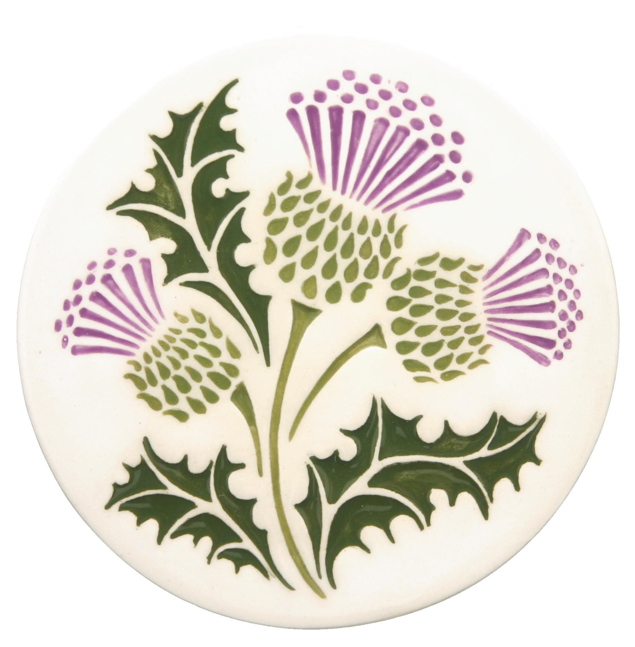 The Scottish Thistle Newsletter
Winter 2017 Volume 2 Issue 1

Scottish Events Reports
Oregon Scottish Society Tea
October 15, 2016
Albany, Oregon
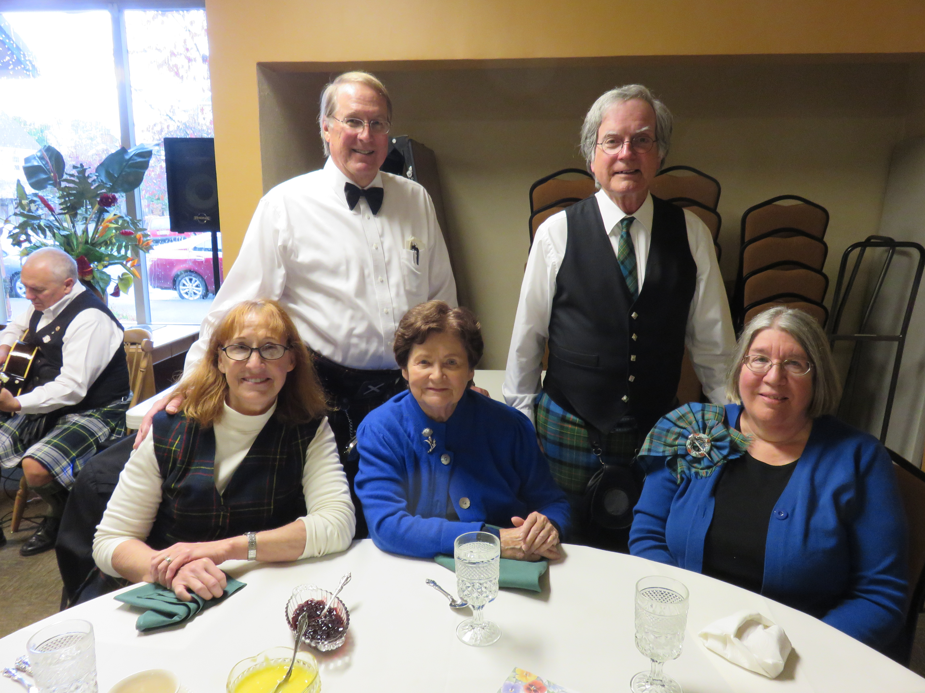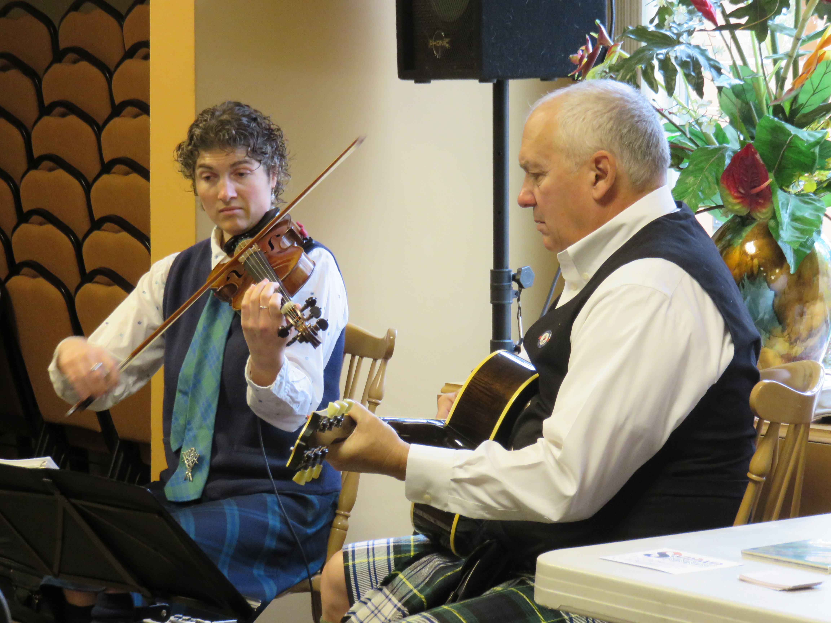
WDCMS group at the Scottish Tea in Albany, Front row – Penny McLaren, Entertainment by D’n’A
Barbara Gard, Margaret English; Back Row – Tim McLaren & Norm English

This was a great opportunity to taste some wonder food items at a nice formal Scottish Tea. A four-course meal of tasty delights, salad, scones, sandwiches, and dessert, and all the tea we could drink. The event also provided a chance to engage in conversation with other Scottish friends in a more formal setting. The entertainment was delightful too, with celtic music provided by the D’n’A, a very talented pair of musicians, who didn’t mind answering questions about their music and otherwise engaging in conversation when they weren’t performing.

Dulcimer Raffle – “And the winner is…..”

Jane Wille – Salem, Oregon

Message from the President – Nina Garcia
Dear Fellow WSCMS Members:
Happy New Year to you all. I have great hope that 2017 will be good and full of happiness and prosperity for our small group. At least I raised my glass to that as we toasted in the New Year. I also hope that the phenomenon labeled, “Arctic Chill”, by the weather experts, hasn’t left anyone too frozen. Remember, there are always some of us around to bring some warmth and good cheer to a blustery winter day. Don’t let the weather leave you feeling isolated or alone. Reach out, there will be someone to cause trouble with – or at the very least, help shovel snow!

I don’t make New Year’s resolutions – I never keep them – so it seems such a waste of good intentions – but, while we’re busy trying to be prosperous, let’s not forget those less fortunate – a little good intention can go a long way in the right direction.

On another, completely different note – some time ago I came across a BBC publication (I think it was BBC), called Hairy Bikers – something or other – it was a recipe book of sorts. It had a recipe for creamy parsnip and apple soup – which I didn’t copy down. This weather seems perfect for such foods – so the thought of the lost soup recipe got me to thinking – maybe you’d be willing to share some of your recipes – and maybe we can put together a recipe book of our own!

In the meantime, be good to each other, stay warm, eat well, and I’ll chat with you all soon.

Nina

Coming Events in 2017
January 28, 2017 – Robert Burns Supper – Lincoln City, OR
4th Saturday in May - Eugene, OR Scottish Festival
2nd Weekend in June – New Venue for Festival/Games Sponsored by Celtic Heritage Alliance
Lincoln City, OR (formerly the Newport Celtic Festival/Games)
3rd Saturday in June – Prosser, WA Scottish Festival & Highland Games
3rd Weekend in July – Portland, OR Highland Games
3rd Weekend in August – Winston, OR Celtic Highland Games & Clan Gathering
2nd Weekend in September – Kelso, WA Highlander Festival

**CONTINUE TO SAVE THE DATE**
September 23, 2017
WSCMS Annual Meeting
Boise, Idaho - Treasure Valley Celtic Festival

Remember to check out our website:
http://westerstatesmaclaren.weebly.com/
WSCMS Membership as of December 31, 2016
Wa Or Id Co Ca Mt Wy B.C. Total
4 6 8 2 3 1 2 2 28

Welcome New Members!
Carol Halsey (October, 2016)
Kerri S. McDill (October, 2016
Leesa L. McDill (October, 2016)
Nicholas W. McDill (October, 2016)

Dues notices were emailed out in December; dues are due January 1, 2017

The deadline for the next issue of The Scottish Thistle is April 1, 201717January

A couple nuggets from your Vice President – Norm English
Since our newsletter is entitled The Scottish Thistle, I thought I would pass along a nice little story from the November/December 2016 edition of The Highlander magazine. The tale, or perhaps some recording of actual history, no one seems to know for sure, all happened in 980 A.D., when Scotland was ruled by King Kenneth II, great-great-grandson of Kenneth McAlpine, who united the Picts and the Scots to form the Kingdom of Scotland. In the lead-up to the Battle of Luncarty, the Danish invaders began their march westward across Scotland, looting and pillaging as invaders were known to do. The Scots had been assembled for a battle with the Danish invaders, and when the Danes began the charge for battle, someone let out a piercing scream alerting the Scots, and the defensive battle was on.

At some point in the pitched battle, even though the Scots had the upper hand, they temporarily broke off the engagement to finish off the downed Danes. As the invaders re-grouped and began to advance again, a farmer by the name of Hay, who was ploughing near the field of battle with his sons and seeing that the king was in trouble, unyoked their oxen and attacked the Danes with the yokes and any other farm implements that came to hand. The king’s men, with the help of the Hay family, got the upper hand over the Danes. Upon his return to Perth, the king ennobled Hay but also loosed the king’s falcon and gave Hay all the land covered by the bird in one flight.
After the battle was done, the story had it that the Danes, to preserve the silence of their advance to battle, had removed their boots. However, when a barefoot Dane stepped on a thistle, he screamed in agony. King Kenneth was so taken with this explanation, that he declared the Scottish thistle to be the national emblem of Scotland.

One other gem for me to mention is the following, you probably noticed in the membership report of this issue that we have added several new members since the last issue. We now have 28 members in total in seven Western states and one Canadian Province. So, keep on getting the word out to potential MacLaren’s.
Norm

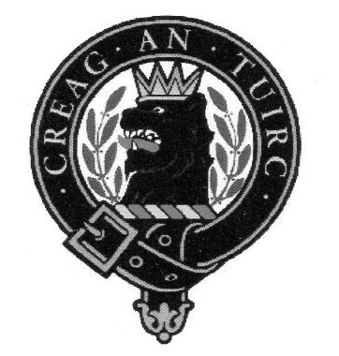

Western States Clan MacLaren Society, Inc.
2016-2017 Officers/Board Members

President Vice-President Secretary
Nina Garcia Norm English Karen Woodall
nina.clanmaclaren@gmail.com (503) 874-8101 (360) 576-4969
normengl@msn.com starcars8@comcast.net

Treasurer
Tom Martin
(208) 764-2882
motor1137@yahoo.com

Board Members
Barbara Allen Gard Margaret English Pete Woodall
(971) 599-5759 (503) 874-8101 (360) 576-4969
barbara.allen.gard@gmail.com mdeng59@live.com starcars8@comcast.net

Tim McLaren
(360) 546-2271 drtmclaren@msn.com

Webmistress
Tracey Martin
(208) 764-2882
tntawards@earthlink.net
Western States Clan MacLaren Society, Inc.
WSCMS, Inc. is a duly registered non-stock, non-profit organization incorporated in 2015 under the laws of the State of Idaho
The Scottish Thistle Newsletter is a quarterly publication printed expressly for WSCMS members

