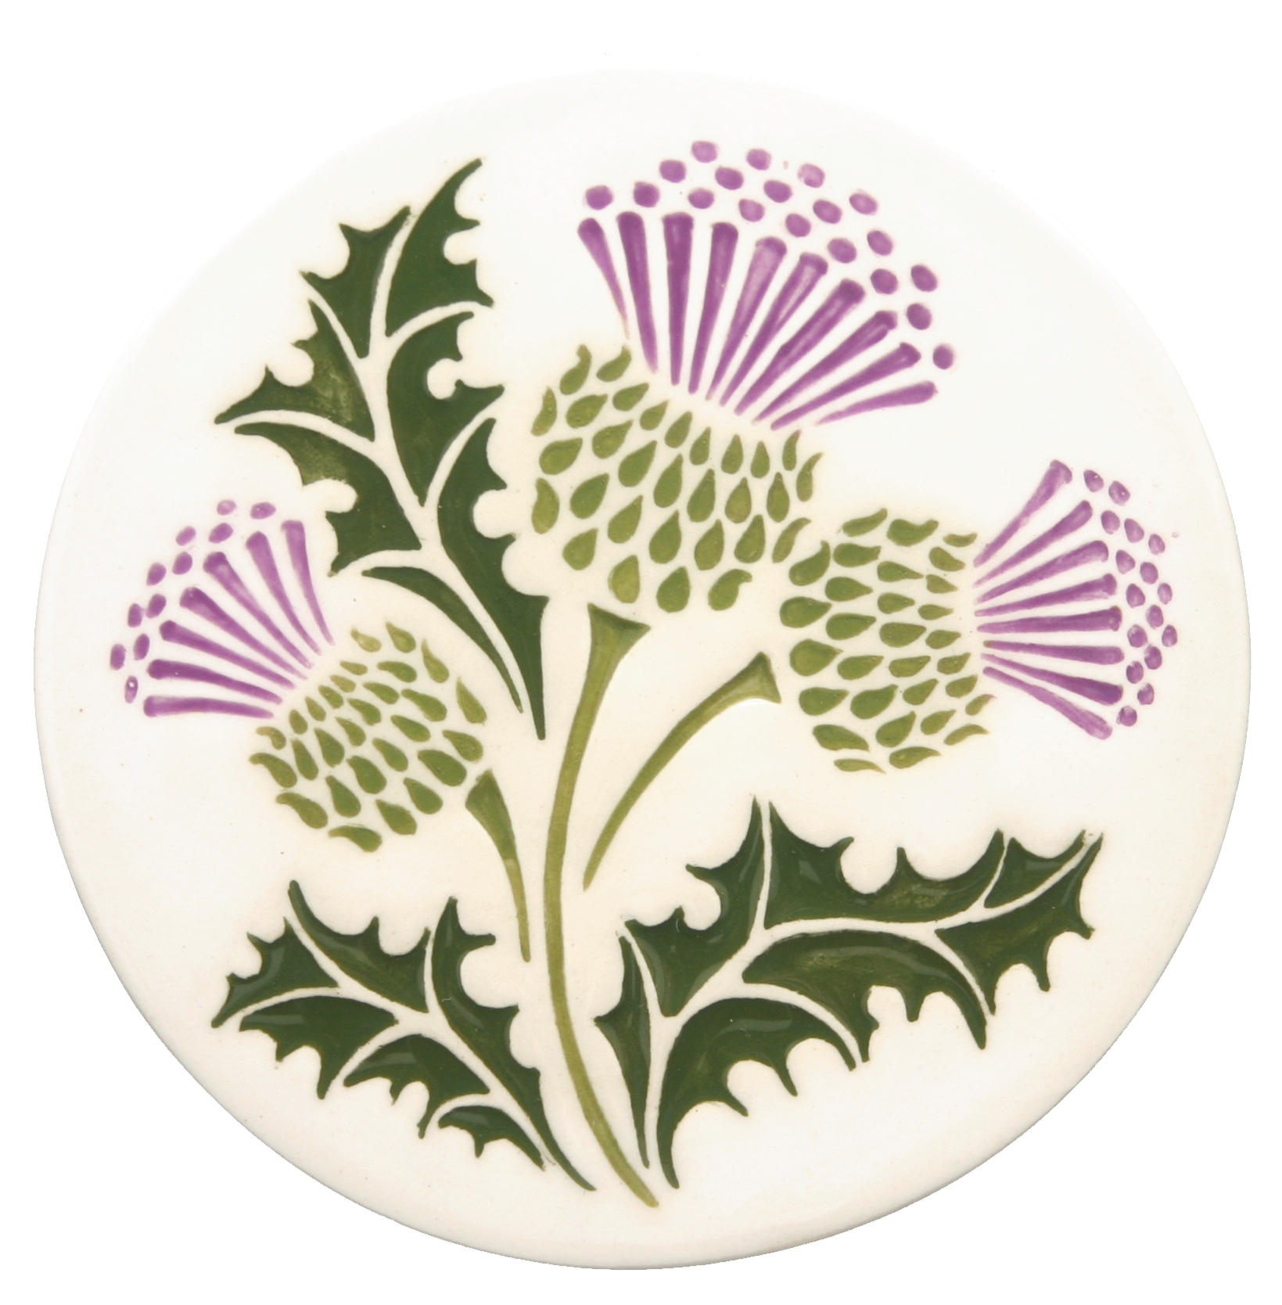 The Scottish Thistle Newsletter
Spring 2017 Volume 2 Issue 2

Editor’s Note: This is a portion of a story written by Nancy Jennings, staff writer for the local Silverton, Oregon newspaper, Our Town, about Norm English, also WSCMS Vice President - I was encouraged to include it in this edition of our newsletter
Norm English – Silverton’s Distinguished Service Award Winner
Norm English likes wearing different hats during his strolls in town. One can say he has been hanging his hats on many community projects over the years. Born and raised in Silverton, English, 72, is delighted to receive this year’s “Distinguished Service Award”.
His volunteer community service projects include eight years at S.A.C.A. (Silverton Area Community Aid), three years as Congregational President at Trinity Lutheran Church, and four years as President of the Silverton Mural Society. He was appointed by the mayor to be a member of Silverton’s Historic Landmarks Commission and served nearly three years. He was a member of Silverton’s Tourism Promotion Committee for nearly three years and helped disperse grants to various organizations. He was President at the Silverton Country Historical Society (SCHS) for four years.
Jane Jones, member of the SCHS, nominated English for the award. A fellow community volunteer, she noticed his involvement in many projects around town. “Every time I was anywhere I would see him volunteering and I just felt that he should be recognized,” Jones said. English is thrilled.
“It’s a fantastic honor. My efforts have been recognized. I think we all do things that are above and beyond in a lot of areas in our lives, but sometimes we just fall under the radar. I’m very pleased,” he said.
English was the visionary of Silverton’s Fallen Heroes Memorial Plaza, which made its existence official on Veterans Day 2015 at a special dedication ceremony. “For the first nine months of that project, I was the only committee member,” he said. He was involved in the three-year project from start to finish. “It’s rewarding when you see family of some of those fallen heroes and talk to them.”
Chris Schwab, secretary at the SCHS, appreciates English’s get-it-done attitude. “He is not the kind of person to be a part of an organization and just sit back,” she said.
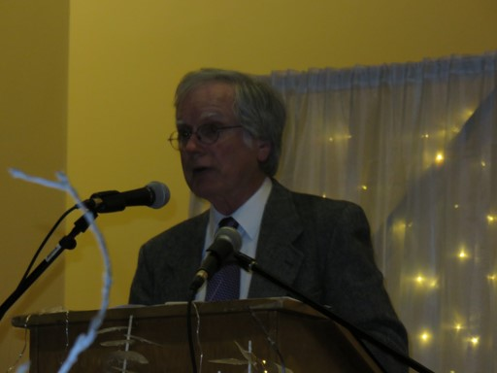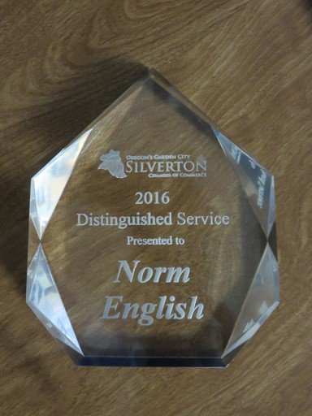
Norm English receiving his Distinguished Service Award from Silverton Mayor Rick Lewis (L), giving his speech (C), and the award itself (R). He received a standing ovation from the crowd of 200+ – February 4, 2017

Mountain Dulcimer #11 by Bob Sewell, Jr.
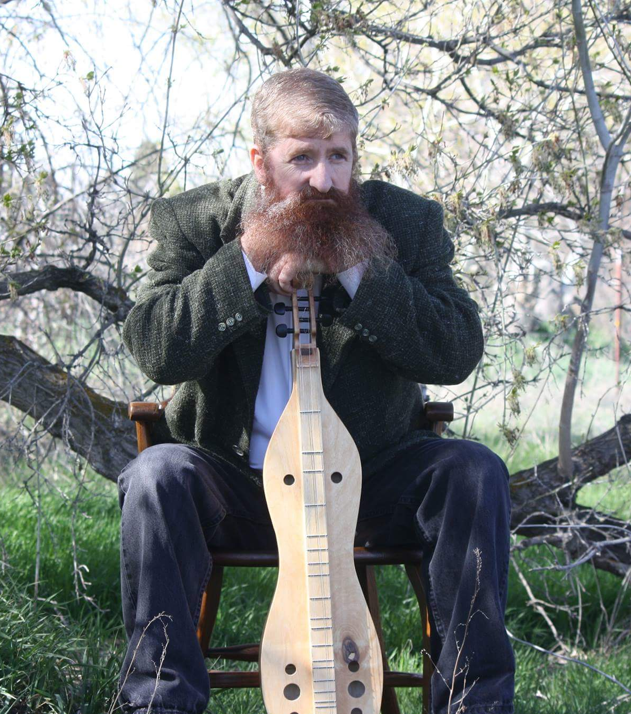
All stories have a beginning. The beginning of this story, as everyone knows it…starts somewhere in the middle. Here, for the premium subscriber (that’s you)…this is the rest of the story.
In 2015, I donated a handcrafted mountain dulcimer for the WSCMS annual fundraiser. The Society would choose what charitable cause the funds would benefit. It was supposed to be a simple arrangement. It was anything but.
About the mountain dulcimer: It is an American instrument indigenous to the Southern Appalachian Mountain range. Commonly found among the Scots-Irish families, musical porch gatherings involved stories being told and kids dancing to bluegrass music. It’s about as common as a frying pan…some homes have more than one. Its unique hourglass shape, handcrafted from wood, is truly a sight for anyone to see. It’s melodic, harmonic sound is unique unto its own. It’s a happy marriage between the sound of bagpipes, violin and banjo.
Many of our heritage songs tell stories. If someone died, got married, got caught doing something or had an extra special hellion as a child, the story was told through a folk song. These songs were memorized and sung repeatedly, to a point where the story has long outlived the tellers of it.
This story in particular is about music, but is better told with the music imagined in our hearts, instead of being through song. Trust me, you can’t make this stuff up. This is the music of silence.
Mountain Dulcimer #11 began its assembly of raw parts in February 2015. The goal was to make a musical instrument that would be donated for the MacLaren clan 2016 fundraiser. This simple goal was supposed to have a simple ending…but, oh no…there’s nothing simple about our family, is there?! We Scots pride ourselves with being big-hearted, strong and fully able to stand some strong drinks. Oh, let’s not forget…we always love a good story.
It’s why we exist.
First item of business: This is a cause near and dear to my heart. The family chooses the cause, but this was an
opportunity to do something culturally significant. It would have merged the crafts of the past with the compassion of

the present, in hopes of inspiring the future. The design of this particular dulcimer would be specifically focused on the projection resonance. When you strum the strings it would resonate extra loud. It’s a simple concept, but it required some effort. What was the purpose? It’s commonly done for church instruments or concert instruments where the lovely music can fill a larger room for larger crowds.
Extra focus went into designing a resonator hidden within. Handcrafted from scratch…installed with no plans for announcement or fanfare. It’s a vibrating sound board that reflects sound and amplifies at the same time. It was so secretive that hardly anyone knew that it was there. I’ll come back to this in a bit…just remember the “resonator”.
I must confess that I’m a dulcimer maker…not much of a dulcimer player. I can strum out a simple melody to prove it makes sound, but that’s about as far-reaching as my musical talents go. I’m a 9th generation dulcimer maker whose ancestors had made dulcimers far and wide throughout Eastern Tennessee. The Mayes dulcimer makers of the past would have been proud. In fact, loud and proud were the ancestors, as the resonator performed flawlessly. Yes again…the resonator…the thing no one knew about.
There is a rare mark on this dulcimer that I had installed to indicate that this mountain dulcimer was a special one. Few of my dulcimers have this mark, but the ones that do, honor my ancestors with the mark of diamond sound holes. This dulcimer honored my Scottish heritage, and their dulcimer making craft.
I hadn’t always been a dulcimer maker. In fact, dulcimers hadn’t been on my mind since 1970. The knowledge of the craft wasn’t passed on. My great-grandfather “Pappy” Eli Mayes, a dulcimer maker himself, didn’t receive much interest from descendants in picking up the craft. It’s hard work. One dulcimer takes about eight months of special attention to details.
My mother is deaf. Because of this, she was sent to live on campus at a deaf school in Utah. The culture of musical storytelling of our people met with silence, and a new generation had begun…lost. The tradition of music was destined to not pass on to me.
Flashback: In 1970, I recall standing in Pappy’s living room, looking in amazement at this wooden instrument that laid on the buffet table. The way the curly maple moved like a tiger’s eye rock was mesmerizing. A stern voice echoed saying, “don’t touch it”. Pappy wasn’t one to mess around. I knew I held my fate within inches of my life. Still I was mesmerized by the curves, design, and the beauty of such an instrument. I had never seen anything like it before. It was ‘eye candy’. I knew better than to touch it. It wasn’t mine. I just wanted to study its beauty…to which I was rudely interrupted once again with a stern voice (as recalled by a timid 5 year old)…”don’t touch it”. I remember being
annoyed, but I knew I was testing the threshold of my lifespan. I just knew that I might die that day. I had no desire
to tempt fate. I was unable to take my eyes off of it. I never touched it, though I’m certain it would have been worth it
if I’d tried.

My great aunt Rutha Mayes came into the room with the sweetest disposition and asked me if I would like to hear what it sounded like. She must have read my mind, because she grabbed the mountain dulcimer, laid it across her lap as she sat down, and played the most beautiful melody I had ever heard. My soul danced. That song embedded itself so deep within my soul that I’ve not forgotten its magical sound to this very day. That memory came back to life in December of 2014. It was then that I asked Google, “what looks like a violin, but sounds like bagpipes”? The ‘smarter-than-I’ search engine suggested that I look into Mountain Dulcimers. After looking at a collection of images…yes, yes, yes…that’s it. The beautiful instrument that laid atop Pappy’s buffet table was called a mountain dulcimer.
My quest then grew from a single memory to contacting every family member that I possibly could. Does anybody have any information about Pappy’s dulcimer? Sadly, the answer was no, but I learned a lot of other things. Family notes, pictures of old instruments, all the possible stories that could be recalled came to light. There was among the trove of treasures a mountain dulcimer built by my 6th great-grandfather Johnson Mayes. It was nailed together with wooden nails. One person even had an audio recording of my great-aunt Rutha Mayes playing the mountain dulcimer. Yes, it was every bit as magical as I recalled. My daughter bought me a set of mountain dulcimer plans for Christmas. Like a sponge, I absorbed as much as I could of this culture I had no idea even existed. Within me, my heritage bloomed, my connection with my ancestors flourished.
With information in hand, I met with a well-known lutherie (master craftsman that works with stringed instruments). He does maintenance work on a private collection of violins by Geshu and Stratavari. Through his kindness and assistance, I was able to learn the many secrets of my ancestors’ craft. I will forever be a student humbled by the many discoveries. My work is not perfect. I will always strive for perfection. I ride on the shoulder of giants. I credit them.
On the evening of a St. Andrew celebration gathering in 2015 in Fairfield, Idaho…my girlfriend Deanna and I were in attendance at this celebration, with three mountain dulcimers in tow. It was a snowy night, and road conditions were poor. We had just driven 45 miles from Gooding, Idaho to take part in a very special night. It was a night to honor the birth of St. Andrew, the patron saint of Scotland and also the first Disciple of Christ.
I had handcrafted all three dulcimers from scratch, and each one was filled with personality. Sharing a bit of Scottish cultural art form, it was an opportunity to share a piece of our love for music. There was great food, wonderful company, and just about EVERYTHING Scottish. It was amazing.
At the gathering, Dulcimer #11 was presented to a member of the clan, Jean Christodoulou. During the festivities, it had been passed around and enjoyed by many of the guests. Amazingly, a couple of the guests knew what a mountain dulcimer was. One guest in particular was the owner operator of the local newspaper. He played us a tune. It was nice to hear how it was supposed to sound in song. It was a pleasant surprise.

Mountain Dulcimer #11 went on a tour in the Pacific Northwest through a portion of 2016. At the highlander festivities, it was displayed for the public to see, and was the winning prize for a raffle being held by our clan. In September of 2016, Deanna and I made the trip to Boise, Idaho to the Treasure Valley Celtic Festival. This special appearance had an agenda…the mountain dulcimer was in need of some attention. The viola tuning pegs weren’t keeping a tune. They were loose and not tightening down.
Fortunately, I had brought with me a small bag of repair goodies for anything that may need attention. I reunited with an old friend that day…old Mountain Dulcimer #11. Memories of the dulcimer came flooding back (including the resonator). I managed to open a small lip balm jar filled with a mixture of tree sap and Spirit (yes, a dab of whisky). Ibrushed it onto the viola tuning pegs. Ahhh, that’s better…the tuning pegs were grabbing hold, but still allowing turns. Blessed be, this rescue mission was a success.
As I worked on tuning the instrument, one string broke. Panic set in…I looked in my bag and luckily, I had packed a set of fresh strings. “Whew” I went ahead and replaced all the strings, tuned it up…and played several melodies for the browsing crowd. We had some tickets to sell for the raffle. Our charity needed help. It was time to sell, sell, sell.
Deanna, Nina, and Robyn sold raffle tickets as I demonstrated an old friend, #11, with the hidden resonator. Yes, the resonator still remained a secret between the instrument and its maker. Oh, it was working better than expected. It made me proud.
You see, there was a nearby ‘bouncy house’ which had a loud and boisterous motor, but with Deanna selling tickets, I was able to play it loudly enough to prove it made noise. Secret weapon…the resonator…a pivotal moment in proving one’s self, but that wasn’t the moment I was waiting to announce.
What I didn’t learn until later was, while I was offering maintenance on an old friend…Dulcimer #11, Deanna had bought a raffle ticket for each of the eight kids between us, two nephews, and six grandchildren. I believe there may have been about 20 names in all. Deanna then conveyed…”this one ticket…this is the ticket that I hope wins”. The ticket had the name of my nephew who was learning how to play the dulcimer, as well as learning the secrets of the craft. Yes, I’m working to teach my nephew what I can. I remain hopeful that the craft doesn’t stop with me. It would absolutely be special if he won.
The drawing for the dulcimer was held that night. We weren’t present for the drawing. Deanna, Jean, and I were on our way back to Fairfield, Idaho before it were to get dark. I received word, days afterward, who the winner of the raffle ended up being…the WINNER: Jane Wille of Salem, Oregon CONGRATULATIONS!!!
I didn’t know her, but I was excited for Jane. Deep down, I hoped that she appreciated how special this musical instrument is. I shared my contact information in the event that she needed anything. I would be happy to answer questions or assist with maintenance or repairs.

Our sweet, loving, compassionate member Barbara Gard knew Jane Wille. I was instantly relieved that this dulcimer was going to somebody that one of our members knew. I was assured that it was going into a home where music and instruments were greatly appreciated. There’s no greater sigh of relief than to hear those words after having spent eight months building this one instrument.
A few weeks had passed with a bit of sad news appearing. Jane Wille’s father had some health issues, and she would need to go back East to tend to her father. Unfortunately, she would not be able to afford the instrument much attention. Out of the kindness of their hearts, they wanted to make sure the dulcimer went to somebody who
would cherish it and appreciate it. They were kind enough to include me in this discussion.
Somehow word had gotten back to Jane Wille that I had a nephew who was learning how to play the dulcimer and was aspiring to be a 10th generation dulcimer maker. I was deeply touched and humbled that they had chosen my nephew to be the next owner of #11. They had asked for my blessings in which I wholeheartedly approved.
I had contacted my brother to share the wonderful news with him. We wanted to keep it a surprise for Ison (my nephew). He has always wanted his own mountain dulcimer, and I’ve promised him some day, I’d make one for him. His special day was coming, and he had no idea. In fact, he was the only one who didn’t know.
Our sweet Barbara Gard coordinated the logistics of everything from gathering the shipping address and mailing it out. I owe this woman a debt of gratitude that I only hope I can one day repay.
Ison lives with his parents in a quiet country home in Wyoming. The closest town is eight miles away. On a scheduled run to check mail, my brother went to the post office to pick up the package with Ison. When they had gotten home and got settled in, the video camera rolled as Ison looked at this box slightly confused. It wasn’t his birthday, nor was it any other gift-giving holiday. Ison wondered what surprise awaited him and why.
He opened the package emotionally touched to discover that this mountain dulcimer was his. The back story was explained to him, and he felt incredibly blessed. What are the odds?
Blessed indeed…you see…remember the secret resonator that I promised I’d come back to in a bit? Everything happens for a reason…there are no coincidences.
Ison is deaf.
The dulcimer was intended to be a little loud for a reason…and somebody upstairs knew that. I haven’t built a mountain dulcimer with a resonator before or since.
A special thank you to the MacLaren Clan for allowing me the honor of creating and donating the dulcimer for the fundraiser. A special thank you to Deanna, Jean, Nicholas, Nina, Norm, and Barbara for your part in this very special story. A special thank you to Jane Wille for your kindness. I still send prayers to this day that God bless

you all beyond measure. And an extra special thank you to God.
It was one incredible journey for Dulcimer #11. There’s no way this story can be told in a song. Its song lies in its silence…music played by a deaf lad. He really does practice hard and plays well.
Perhaps, maybe we can get together and do this again some day.
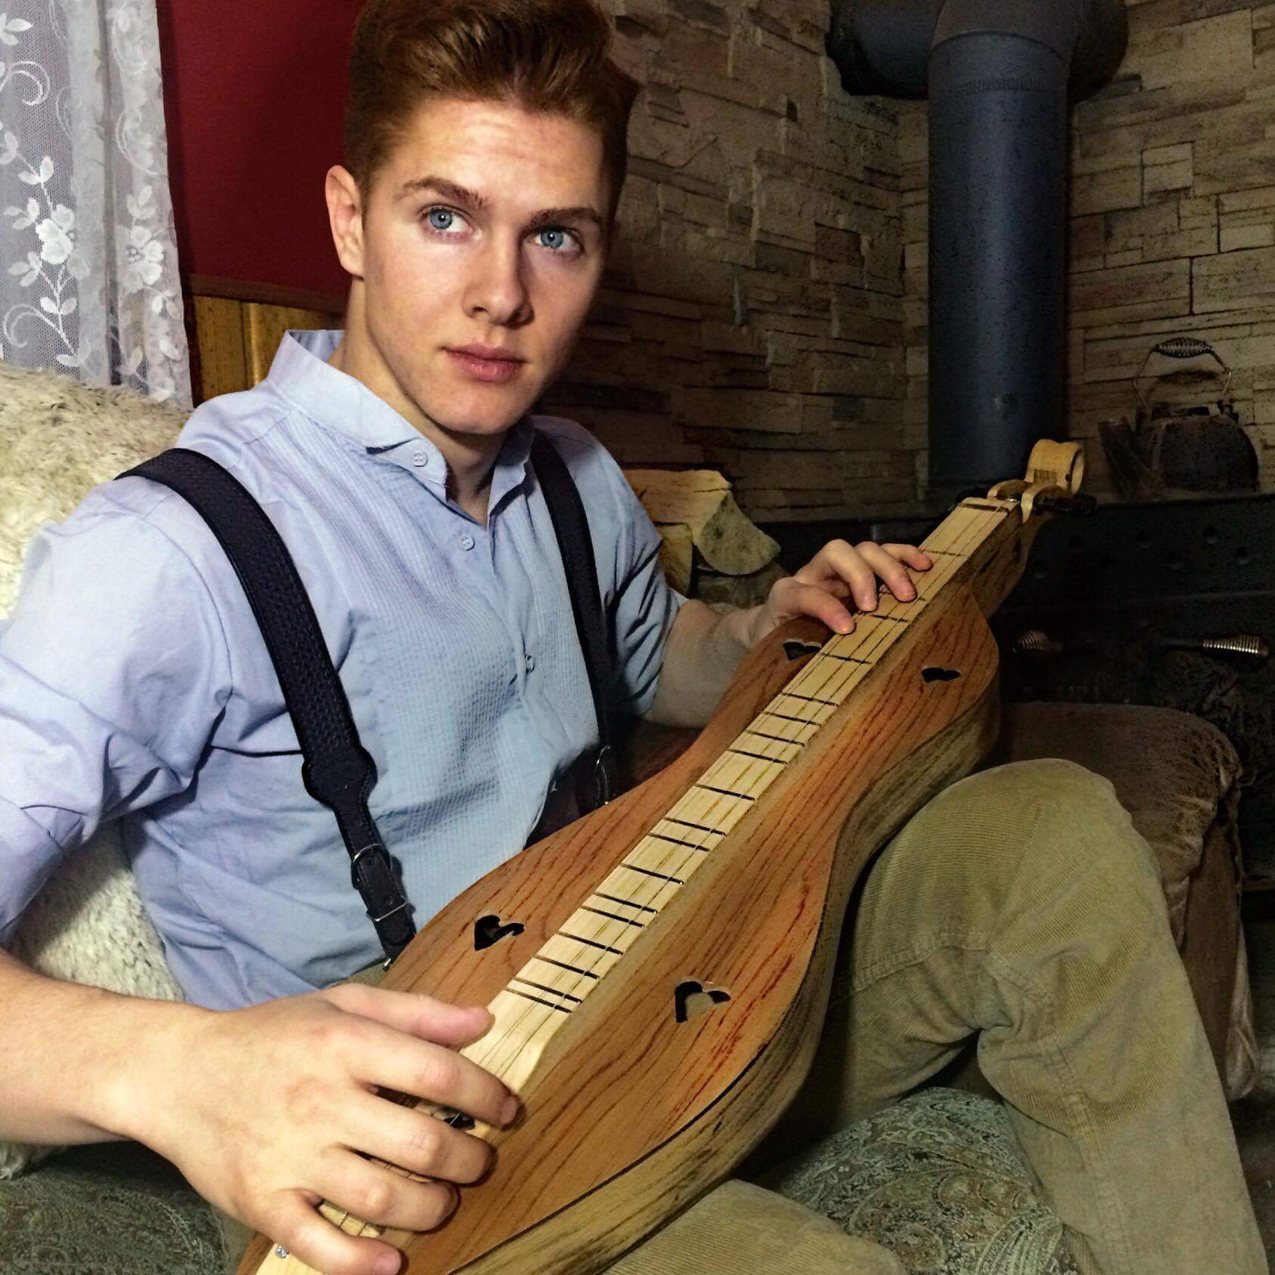
Ison Sewell (Bob’s Nephew), the recipient of Mountain Dulcimer #11
Message from the President – Nina Garcia

Hello Everyone!
We made it through Winter! According to the experts, it was a doozy! I hope everyone has been able to retire the snow shovels and sandbags, rubber boots, mukluks and umbrellas – at least until next winter. I know it’s an overused metaphor, but with Spring and its warmer weather comes new beginnings. For us, that means highland gatherings, band events, impromptu lunches and other fun-filled activities. Yeah!!

While we’re out there having fun, I would like everyone to give a thought to worthy charitable causes for next year. This year, as with last, our fundraising efforts are directed to fattening our society account. But, as meager as that fund is, we should remember that we are much more fortunate, vastly so, than many others in our communities. In the past, we have raised money for the Kirk in Scotland, and combat-wounded amputee veterans in the USA.

I would like us to consider the social obligation aspect of our society, so please give some thought to a worthy cause we can all get behind for next year. I don’t care if all we can raise is $20.00; at least it means that whatever group we opt to support will have our focus and love – for the whole year. I know we’re not a full-fledged service organization like some of the more famous we could name, but as citizens, I don’t believe we can abdicate our responsibilities to our fellow creatures. Your thoughts on this would be appreciated.

Also, be mindful that this is our election year – you’ll hear more on this in the next newsletter – so give some thought to what you’d like to do within our society. There is lots to do – don’t be shy. As a reminder, our AGM will be in Boise this year – September 30 – mark the date on your calendar.

Until next time, I leave you with the words of the late Robin Williams – “Spring is nature’s way of saying, ‘Let’s Party!’” -- Nina

Remembering Robert Burns by Penny McLaren
A few members of Western States Clan MacLaren Society, as well as a few other friends, gathered for a Burns Supper at the home of Tim and Penny McLaren in Vancouver, Washington on Saturday, February 4. Luckily, Liz and Ross Robertson of Vancouver, but originally from Aberdeen, Scotland, were able to attend and gave their excellent, official stamp on the festivities.
Tim McLaren piped in the haggis, marching in with Pete Woodall, who was the whiskey-bearer and Penny McLaren, the haggis-bearer. Ross Robertson gave the address to the haggis, a beautiful rendition in his Scots brogue.
Liz Robertson gave the Selkirk Grace. The company dined on roast turkey (a variation of grouse?) and delicious tatties and neeps prepared by Liz Robertson, who also prepared wonderful desserts of an excellent trifle and a whisky cake.
The main event and the reason for the evening, was an excellent, To the Immortal Memory, given by Barbara Gard. All declared it most inspiring.
The idea to hold the supper was somewhat impromptu, but it was carried off in fine tradition.
Coming Events in 2017
4th Saturday in May - Eugene, OR Scottish Festival
3rd Saturday in June – Prosser, WA Scottish Festival & Highland Games
3rd Weekend in July – Portland, OR Highland Games
3rd Weekend in August – Winston, OR Celtic Highland Games & Clan Gathering
2nd Weekend in September – Kelso, WA Highlander Festival

**CONTINUE TO SAVE THE DATE** - September 30, 2017
WSCMS Annual Meeting – Election of Officers/Board Members
Boise, Idaho - Treasure Valley Celtic Festival

Remember to check out our website:
http://westerstatesmaclaren.weebly.com/
WSCMS Membership as of February 1, 2017
Wa Or Id Co Ca Mt Wy B.C. Total
4 7 7 2 4 1 2 2 29
WSCMS Membership Report
Dues notices were emailed to our 30 members on December 28, 2016
One member notified us that they did not wish to renew
Four members have not renewed as of March 25, 2017
24 Members have renewed or are currently paid through December 31, 2017
Your 2017 dues payment of $10.00 may be sent to: Tom Martin – WSCMS Treasurer, 296 E 400 S,
Fairfield, ID 83327

The deadline for the next issue of The Scottish Thistle is July 1, 201717January

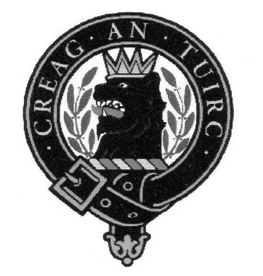Western States Clan MacLaren Society, Inc.
2016-2017 Officers/Board Members

President Vice-President/Newsletter Editor Secretary
Nina Garcia Norm English Karen Woodall
nina.clanmaclaren@gmail.com (503) 874-8101 (360) 576-4969
normengl@msn.com starcars8@comcast.net

Treasurer
Tom Martin
(208) 764-2882
motor1137@yahoo.com

Board Members
Barbara Allen Gard Margaret English Pete Woodall
(971) 599-5759 (503) 874-8101 (360) 576-4969
barbara.allen.gard@gmail.com mdeng59@live.com starcars8@comcast.net

Tim McLaren
(360) 546-2271 drtmclaren@msn.com

Webmistress
Tracey Martin
(208) 764-2882
tntawards@earthlink.net
Western States Clan MacLaren Society, Inc.
WSCMS, Inc. is a duly registered non-stock, non-profit organization incorporated in 2015 under the laws of the State of Idaho
The Scottish Thistle Newsletter is a quarterly publication printed expressly for WSCMS members

