Western States Clan MacLaren Society
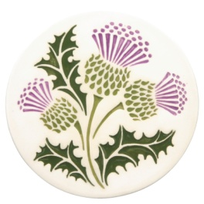 The Scottish Thistle Newsletter
Summer/Fall 2018 Volume 3 Issue 3

A remarkable McMinnville Games and AGM

One word can sum up the experiences of the McMinnville Games and the MacLaren participation: Successful!

From the idea for a restart of the games by the Celtic Heritage Alliance to the results, it was all positive. The attendance seemed good and the festivities well-planned. As for the MacLaren tent on the field, and the dinner and meeting for the society, everything seemed to go well. Although dire weather was predicted for the entire weekend, instead, on Saturday the sun shone. It seemed like we were on an island of blue skies, and the clouds parted above us all day. That was truly remarkable. Sunday’s weather was more along what was predicted, but since we had Saturday to buoy us, we could brave the drizzle of the second day.

The greatest praise should be heaped on Chris McLaran, president of the Celtic Heritage Alliance, who was responsible for the organization, and also on Ray Mabey, who is vice president of the organization, and directed the heavy athletics portion of the entire event, which draw a lot of crowd attention. We should be immensely proud of both of them. They represented the MacLarens and their Scottish heritage very well.

As the photos that follow will attest, the setup of the clan tent by Barbara Gard, Karen and Pete Woodall, Norm and Margaret English, Nina Garcia and the assistance of Tim and Penny McLaren, the end result was also successful. Although there was no competition for best clan tent, they made sure we certainly could have won honors. There was also a clan tent for the Clan MacLaren Society of North America, which caused a bit of confusion for one family looking for others in their group at the wrong tent. But everything was amicable, whether on not we managed to sign up any new clan members. (at last check, we did not.)

Reports indicate that the games made its expenses and there is a strong sense that Chris McLaran and his crew would do it all again next year.

As for the AGM, we probably could not have found a better place to hold our gathering. The setting of the JL Kiff Vineyard was ideal. Laurie Kiff arranged for us the most remarkable meal of barbequed meat and sides. The crowning touch was the cake for dessert with the depiction of the Clan MacLaren tartan on the top. Delightful! Laurie and Joel were the most perfect hosts, and we enjoyed tasting their wines. We wish them much success in their winery business. We owe them endless thanks.

For those who were not able to be there, please plan ahead to attend the games next year. McMinnville is a lovely town and the people seemed to embrace the festivities with open arms.

Thanks to all who helped and visited and supported us in thought. We hope to see you again next time.

WSCMS, Inc. Annual Meeting
McMinnville, Oregon
June 9, 2018
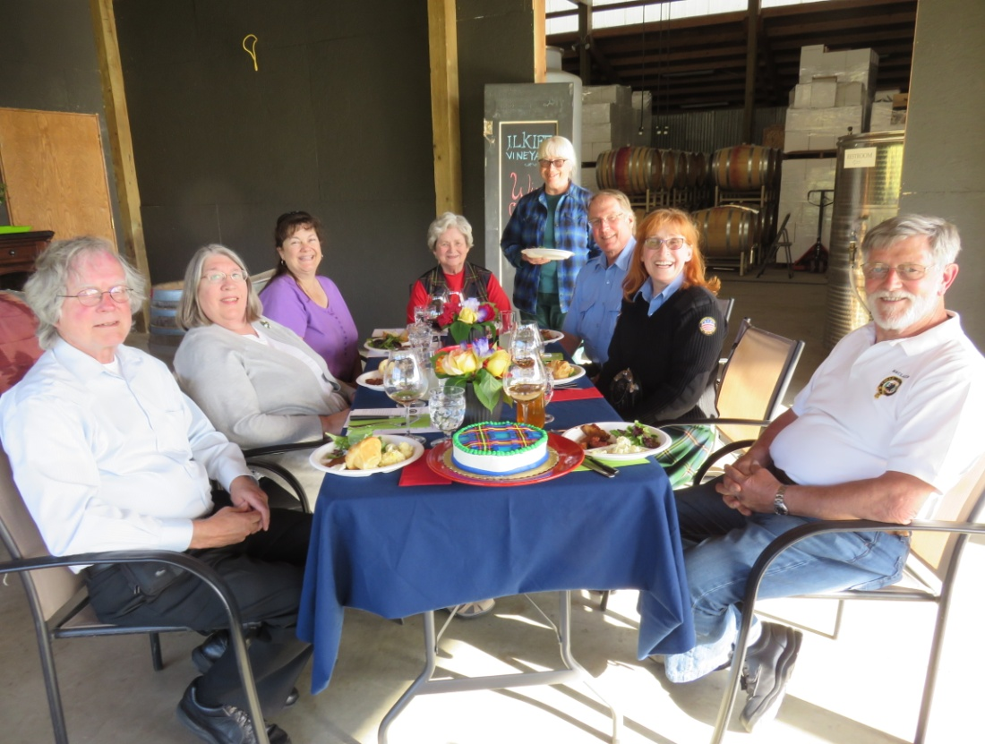
WSCMS Annual Meeting at J.L. Kiff Vineyard, McMinnville, OR June 9, 2018
Clockwise from Left Front: Norm & Margaret English, Nina Garcia, Barbara Gard, Karen Woodall, Tim & Penny McLaren, Pete Woodall (Foreground shows centerpiece dessert – Clan MacLaren tartan)
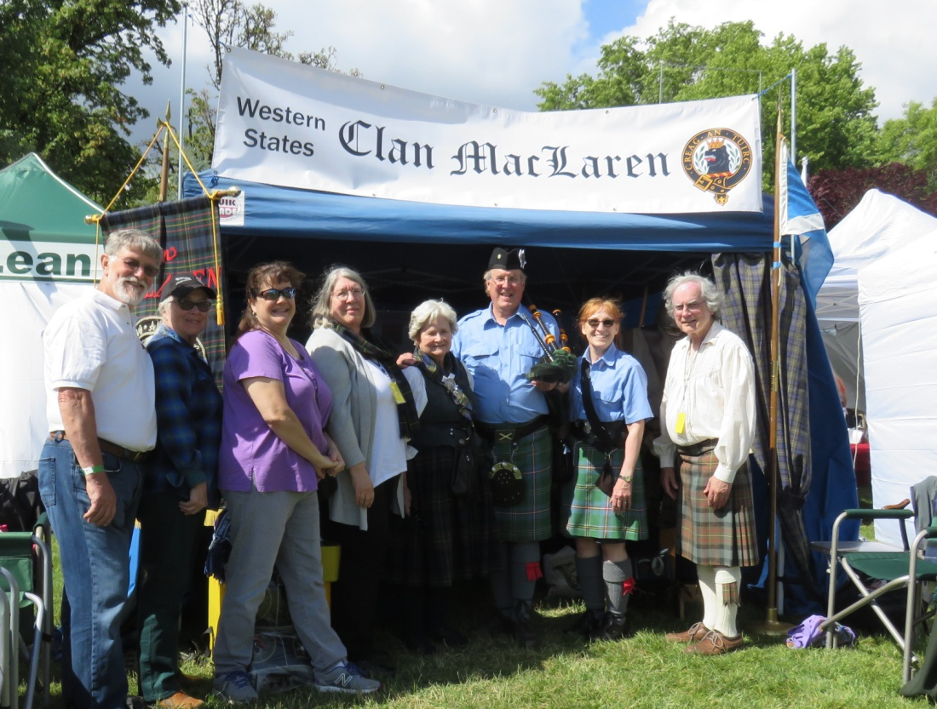
McMinnville Scottish Festival WSCMS Tent – June 9, 2018
L to R: Pete & Karen Woodall, Nina Garcia, Margaret English, Barbara Gard,
Tim & Penny McLaren, and Norm English

McMinnville Scottish Festival
June 9-10, 2018
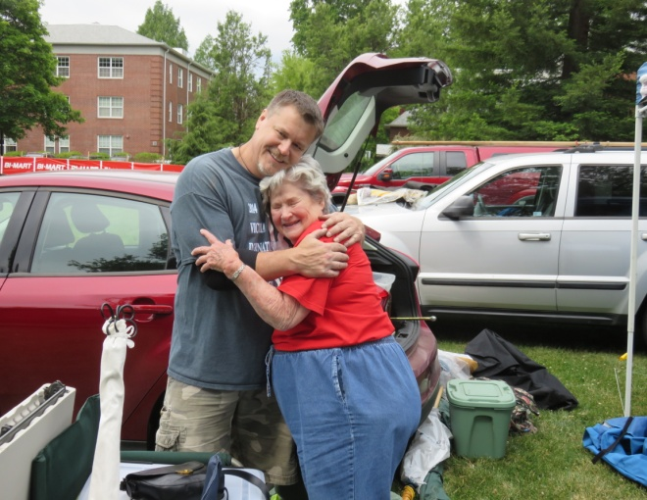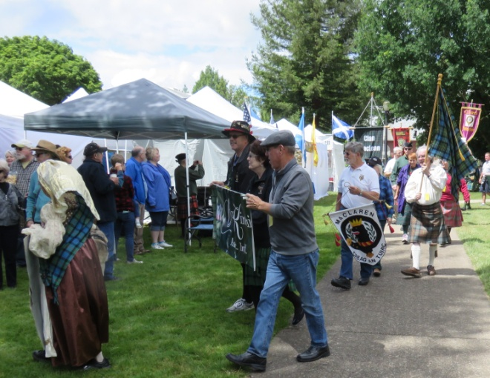
Left: Set-up Day with Ray Mabey & Barbara Gard; Right: Clan March with Pete Woodall, Karen Woodall (nearly hidden from view behind him), and Norm English carrying tartan banner
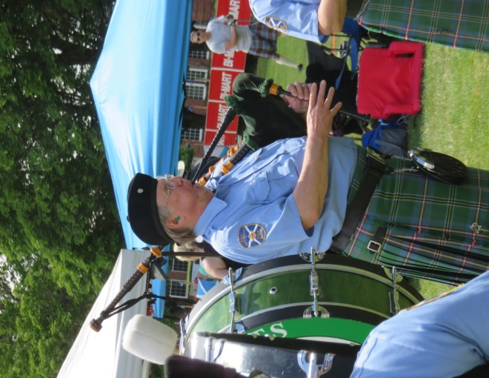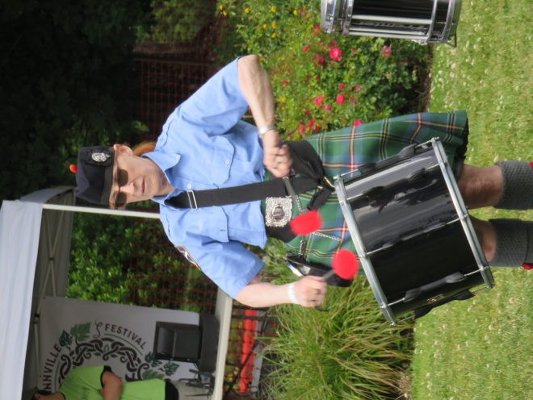
WSCMS members Tim McLaren playing bagpipes & Penny McLaren on drum

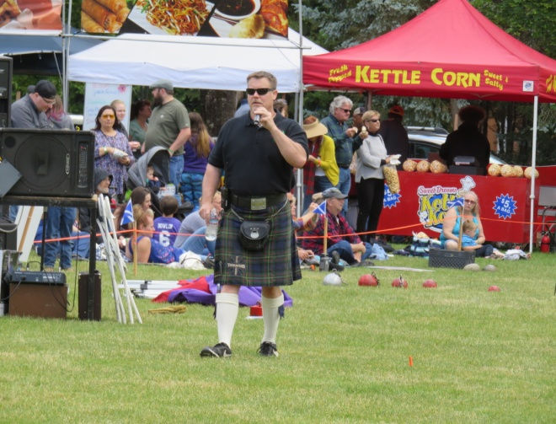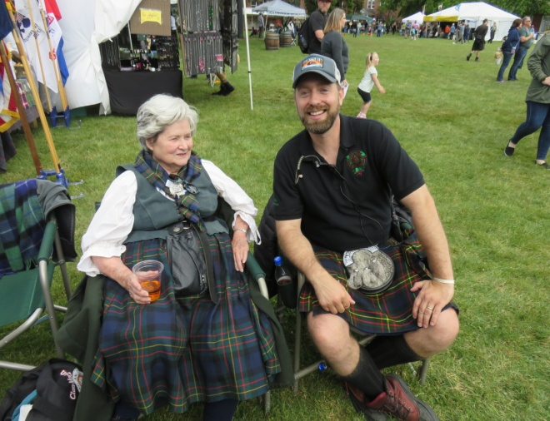
WSCMS member Ray Mabey announcing athletics (L); Barbara Gard chatting with Celtic Heritage Alliance Board President Chris McLaran
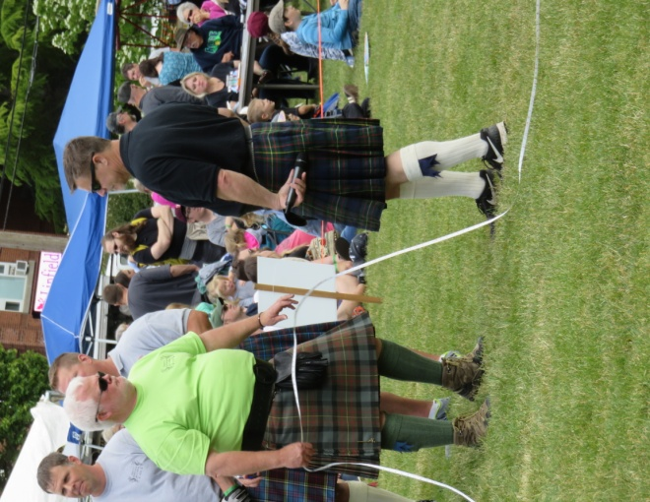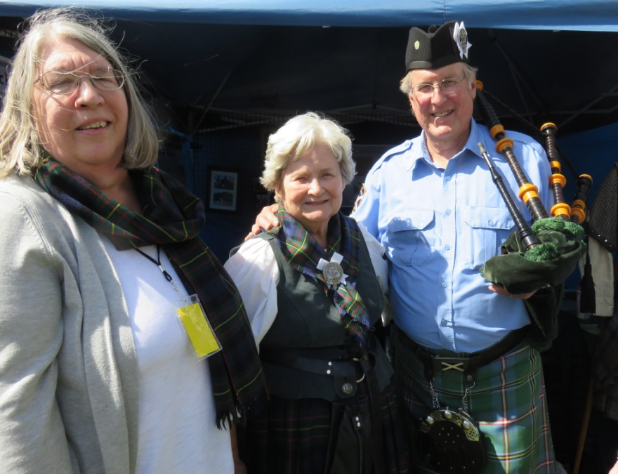
WSCMS members Hal Gard (L) & Ray Mabey working athletic events; Members Margaret English, Barbara Gard and Tim McLaren posing in front of the tent – June 9, 2018

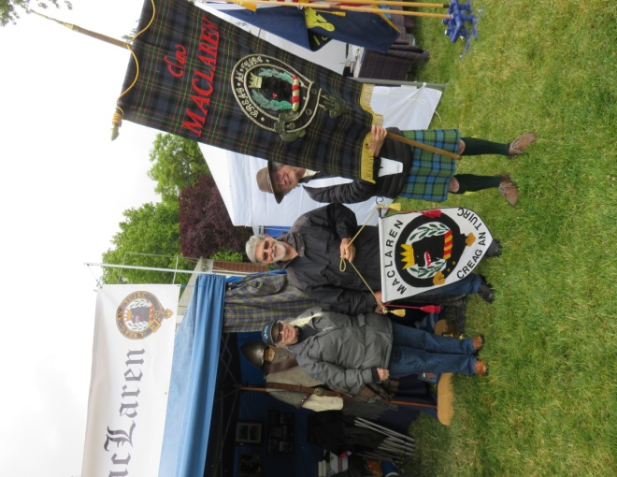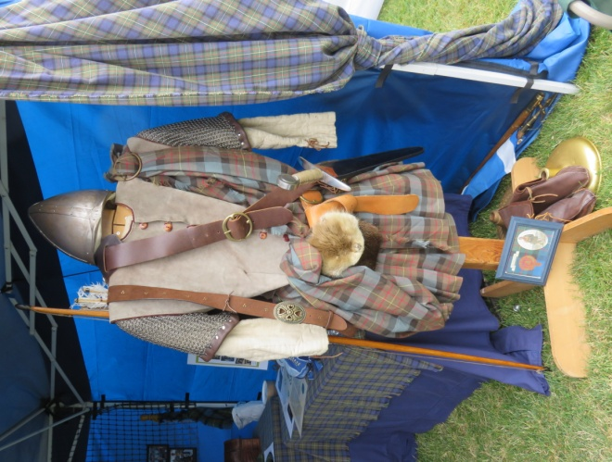
Left photo: L to R: Karen & Pete Woodall and Norm English
getting ready for the Clan March on Sunday June 10.
Right photo: “Woody” on display at the clan tent.

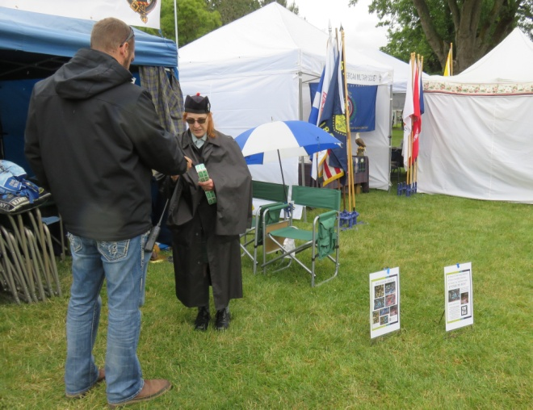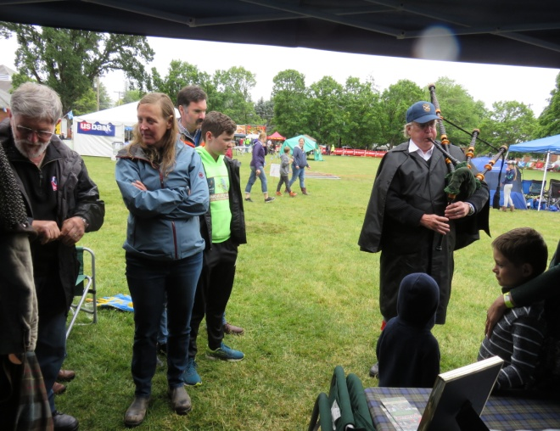
(L) Penny McLaren selling raffle tickets: (R) Pete Woodall explaining features of ‘Woody’ while Tim McLaren demonstrates playing the bagpipes – June 10, 2018

Thank you to the JL Kiff Vineyard for our AGM meeting and dinner location
www.jlkiffvineyard.com
13546 NW Willis Road, McMinnville, Oregon 97128
971-237-6745

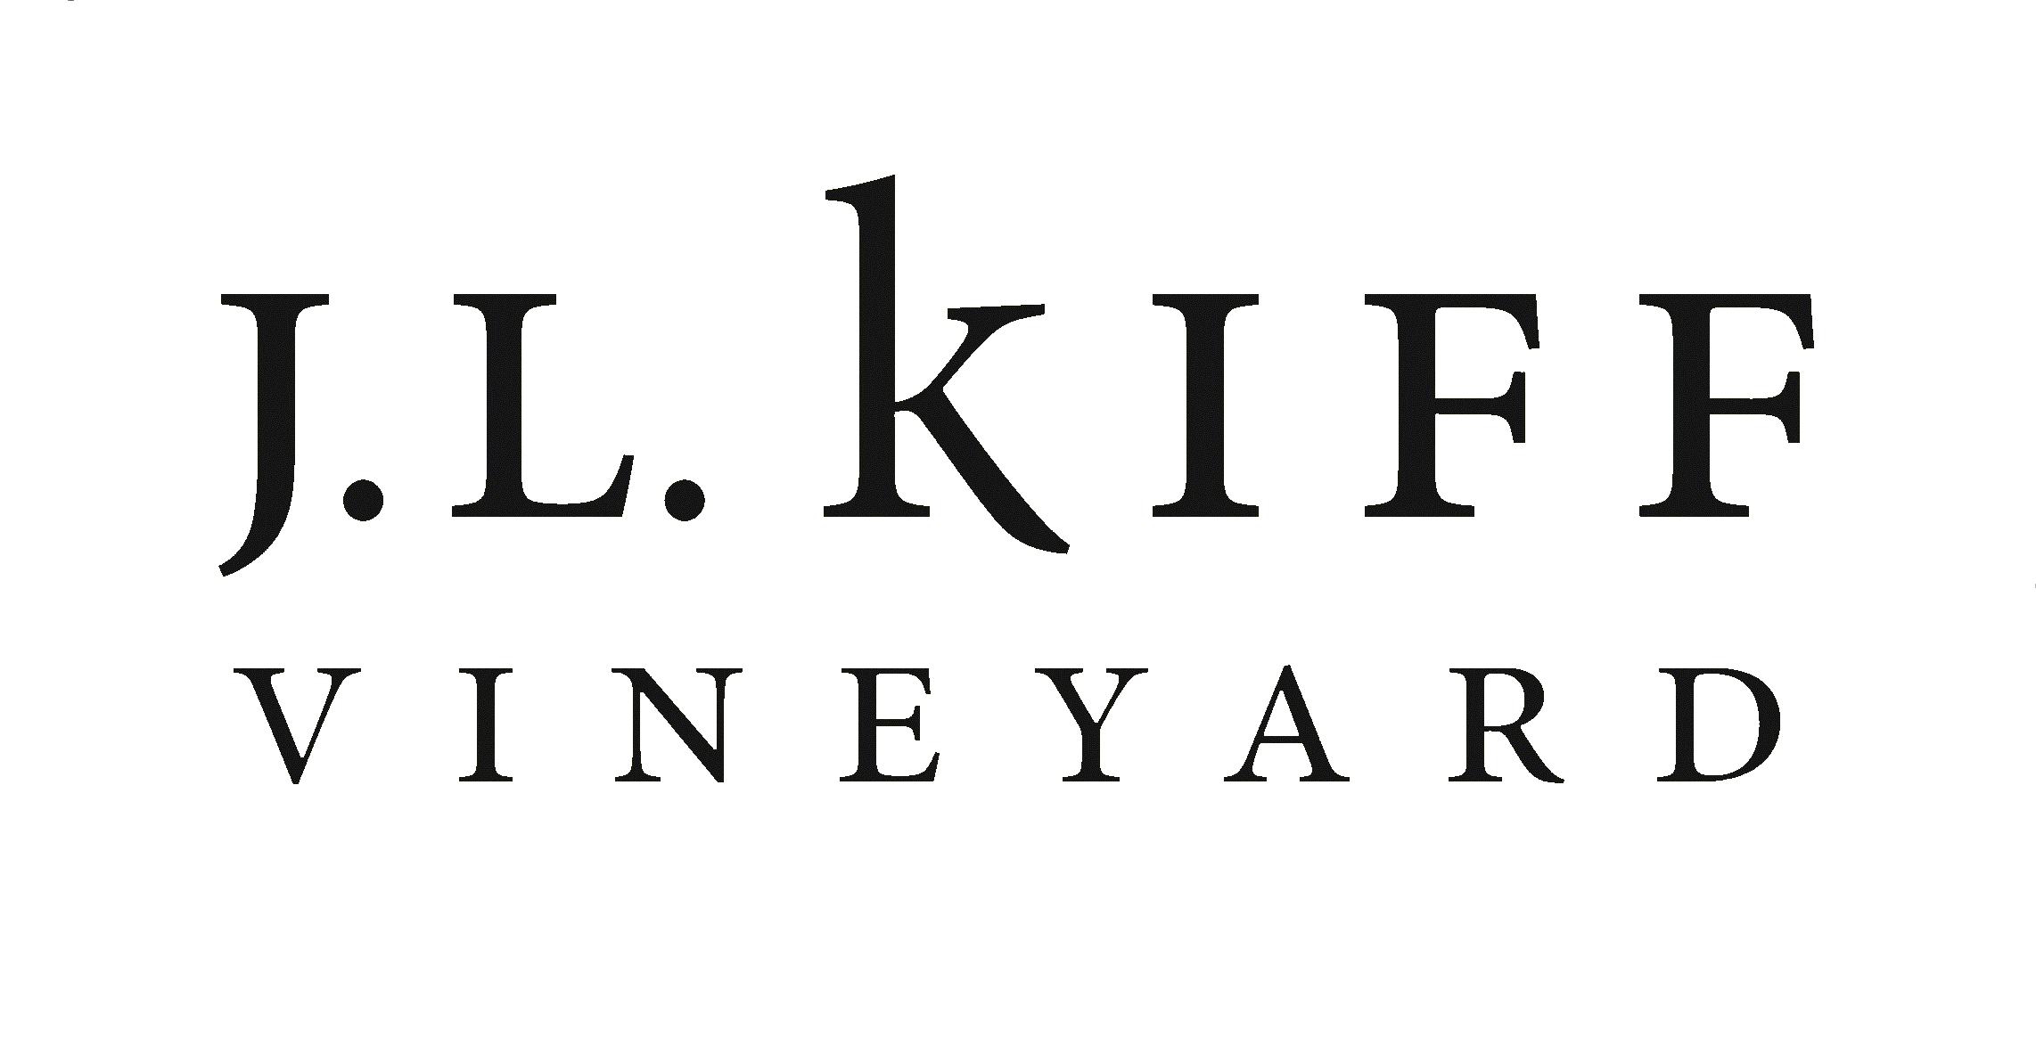

Fund-raising effort at the Games

The MacLarens at the McMinnville Games talked with passers-by and other visitors about the society’s fund-raising project for this year. Proceeds were going to Northwest Battle Buddies. This organization is dedicated to military men and women who have given of themselves in battle. They laid their lives on the line, and upon returning have faced another difficult battle in society, that, for them, has changed. Northwest Battle Buddies trains service dogs at no charge to provide them to combat veterans who suffer from PTSD or other depression. The dogs provide support, security and love to their companion.

About $100 was raised at the McMinnville Games through the raffle and donations. The winner selected the Army throw for the prize. This drawing can be repeated at other games since three more throws and matching pillows remain to be offered. Thanks and such great admiration go to Barbara Gard for creating the wonderful throws. Everyone who saw them wanted to win one! Barbara did a most extraordinary job on them. Thanks, Barbara. You made the day for us and for the organization and people who will benefit from this effort.

McMinnville Scottish Festival 2018
Athletic Competition
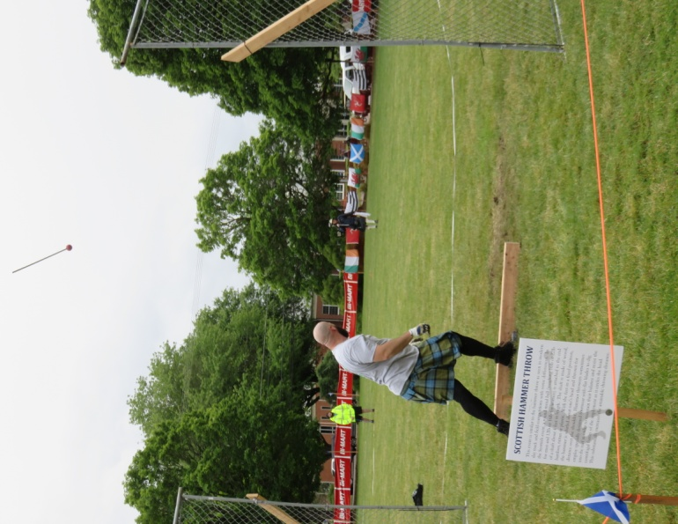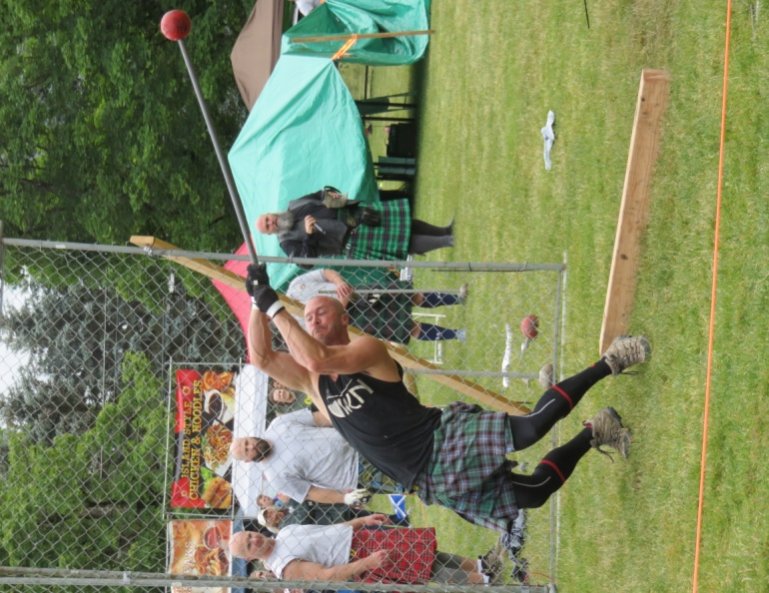

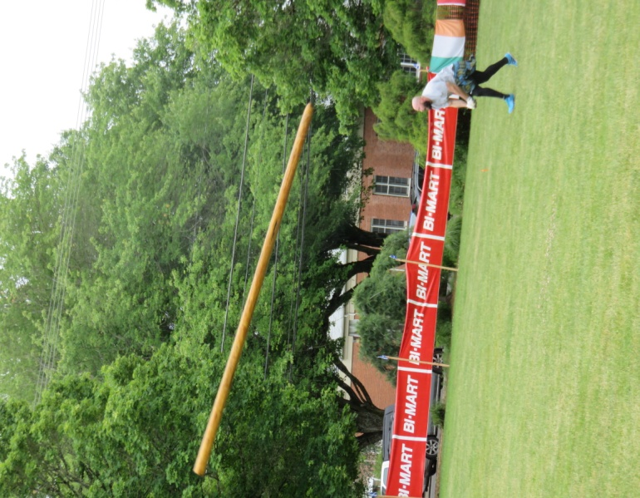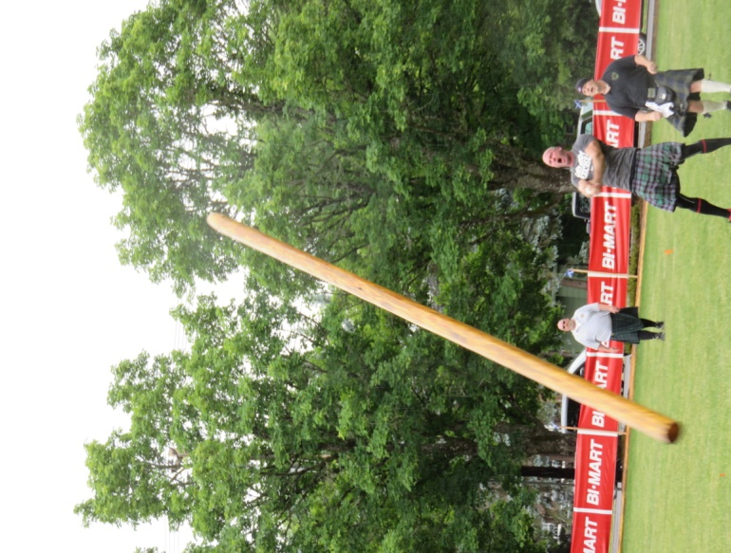
Challenge Caber news: Three pro athletes, John Odden, Mark Wechter, and Scott Hutinson vied to turn the MacLaren Challenge caber on Sunday, but none of them accomplished a successful turn. They did put on a great show.

WSCMS Meeting Minutes
June 9, 2018
JL Kiff Vineyards, McMinnville Oregon

A Quorum was established. The meeting was called to order by the President at 6:07pm.

Present: Nina Garcia, Barbara Gard, Norman English, Margaret English, Tim McLaren, Penny McLaren, Pete Woodall, Karen Woodall

Approval of the Minutes:
The minutes from the previous meeting were reviewed. There were no additions or corrections. Barbara moved that the minutes be approved as written. Norm seconded. The minutes were unanimously approved.

Financial Report:
In Tom’s absence, Norm gave the report. Current Balance: $724.25. Nina moved that the report be accepted, Barbara seconded and it was approved.

Membership:
Tim reported that we have 26 members. Penny moved the report be accepted, Barbara seconded. Report approved.

Website Report:
To access the Western States Clan MacLaren Society web site the entire name must be written out. The site does not come up when just typing Clan MacLaren. Nina will check into the seeing what can be done. There will be a need to have a professional and dollars to fix it.

Tracey has been very active in posting updates, interesting articles and pictures on the Facebook page. There have been many hits on the page.

Newsletter:
Penny may change the format to use the program Microsoft Publisher, to make doing the newsletter easier. Penny requests articles and pictures.

Bylaw Change:
Norm discussed the proposed bylaw change to have a vehicle for someone out of our area who wants to align with our organization. (In addition, membership may be offered to any person meeting the stated criteria of surname and/or interest in MacLaren, who resides outside the geographical boundaries of the society as stated in Article 1 of these bylaws, who is recommended by a member in good standing and endorsed by an officer or board member). This was unanimously approved.

Old Business:
Nonprofit fund-raising discussion around the military themed lap blankets for raffling off at the games. The organization named as benefiting from the funds is Northwest Battle Buddies. Not much activity at the games Saturday, but Nina has many military friends and will contact them as well. The person purchasing a raffle ticket and wins will have a choice of a pillow or the throw. There was a suggestion that those not wanting to buy a raffle ticket can buy a blanket or pillow. Barbara Gard made four throws representing Army, Navy, Air Force and Marines, and two matching pillows of each.

New Business:
The next AGM will be at the Boise Highland Games, in September 2019. WSCMS is a Non-Profit organization registered in Boise Idaho under Nina’s address. It will be changed to Tracey’s address and all incorporation information and renewal should come to the Treasurer at Tracey’s address.

Highlander Advertisement: Penny designed an advertisement with WSCMS contact information and badge which she then submitted. The ad cost $150.00 for one-half year.

Norm put together a historical account of our organization in a binder. There is a quick reference guide, newsletters, minutes of meetings and pictures. A job well done.

Meeting was adjourned at 7:28 pm

Karen Woodall
Recording Secretary

Membership in WSCMS

Thanks for being a member of WSCMS. We hope you will share information about the group with others who want to get together with MacLarens in the western parts of the U.S. Please contact Tim McLaren via the contact information in the society listing that follows if you would like him to send information to a prospective member or if that prospect has any questions. Dues are $10 per year.

Remember to check out our website:
http://westerstatesmaclaren.weebly.com/

Coming Events in 2018
2nd weekend in September—Saturday and Sunday, September 8 & 9, Kelso, WA Highlander Festival
2nd weekend in September—Saturday and Sunday, September 8 & 9 Estes Park, CO Highland Festival
4th Saturday in September—Saturday, September 23, Boise, ID Treasure Valley Celtic Festival
1st weekend in October—Saturday and Sunday, October 6 & 7, Eugene, OR, McKenzie Highland Games

Please share the word about WSCMS.
If you can attend any of the above games this fall or will be attending games in 2019, and are willing to convene a WSCMS clan tent, let us know and we will provide support and materials.

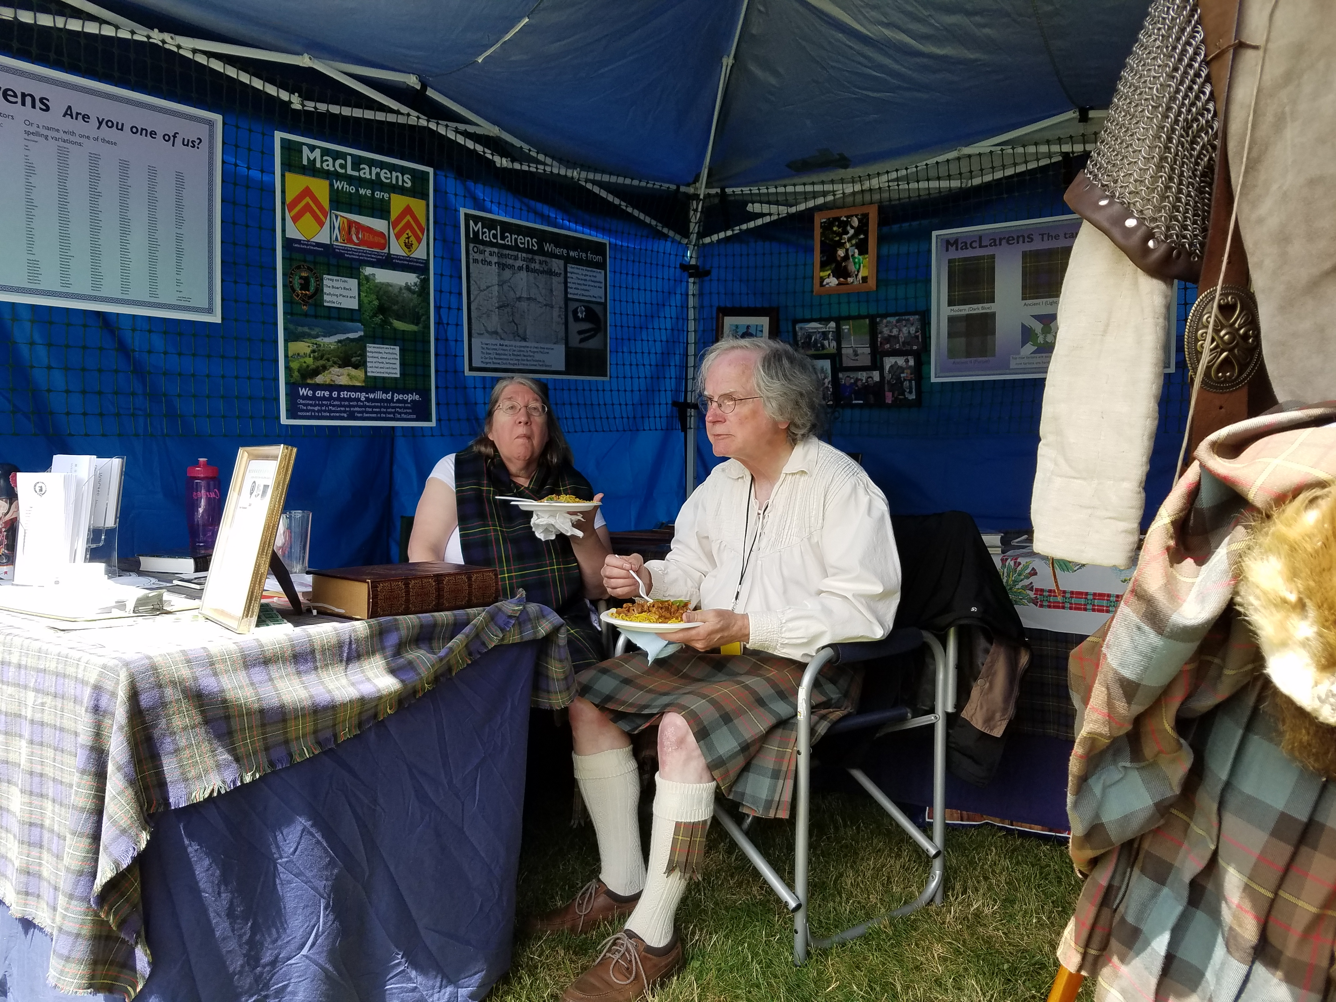
Clan tent interior, with room for Margaret and Norm English to enjoy lunch!
Posters shown can be provided or printed locally.

17January
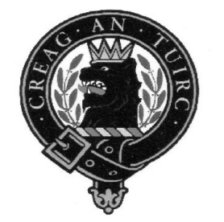
Western States Clan MacLaren Society, Inc.
Officers/Board Members through December 31, 2019

President Vice-President Secretary
Nina Garcia Norm English Karen Woodall
nina.clanmaclaren@gmail.com (503) 874-8101 (360) 576-4969
normengl@msn.com starcars8@comcast.net

Treasurer
Tom Martin
(208) 764-2882
motor1137@yahoo.com

Board Members
Barbara Allen Gard Margaret English Pete Woodall
(971) 599-5759 (503) 874-8101 (360) 576-4969
barbgard07@gmail.com mdeng59@live.com starcars8@comcast.net

Tim McLaren
(360) 546-2271 drtmclaren@msn.com

Web manager Newsletter Editor Membership
Tracey Martin Penny McLaren Tim McLaren
(208) 764-2882 (360) 546 2271 (360) 546 2271
tntawards@earthlink.net ampmcomm@msn.com drtmclaren@msn.com

Western States Clan MacLaren Society, Inc.
WSCMS, Inc. is a duly registered non-stock, non-profit organization
incorporated in 2015 under the laws of the State of Idaho
The Scottish Thistle Newsletter is a quarterly publication printed
expressly for WSCMS members
The deadline for the next issue of The Scottish Thistle is October 15, 2018

