Western States Clan MacLaren Society, Inc.
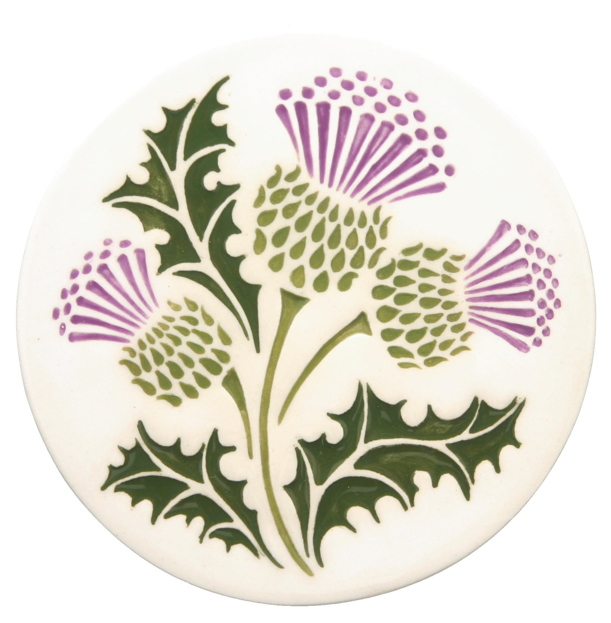The Scottish Thistle 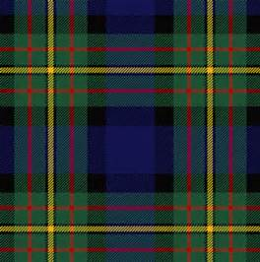
===========================================================================

January 2016 Volume 1 Issue 1

Western Clan MacLaren Society is Formed in Idaho!
This initial issue of The Scottish Thistle is being provided to members of the Western States Clan MacLaren Society, and future issues will be produced quarterly, in April, July, and October. You are receiving this newsletter because you are listed as a member of this society, newly formed in 2015. At the Treasurer Valley Celtic Society Highland Games in Boise, an organizational meeting was held to elect officers, appoint board members, and approve the bylaws for this group. Page 4 of this publication lists the new officers and appointees of WSCMS, Inc. and their contact information. A separate bylaws document will either be mailed to you or provided electronically to your email address.
The purpose of this Society is ‘to foster and encourage interest in the history, culture, and traditions of Scotland in general and Clan MacLaren in particular, as well as providing information and education regarding the same, and to promote collegiality and friendship among members’.
Our Society includes all states and Canadian Provinces either West of the Continental Divide or intersected by it, so by that definition, it’s truly a Western Regional group. It’s truly exciting to have a group that can celebrate its Scottish heritage without feeling tied to an Eastern/Southeastern influence, and without any particular allegiance to a clan chief. We are free to be ourselves, and enjoy our family name and heritage.
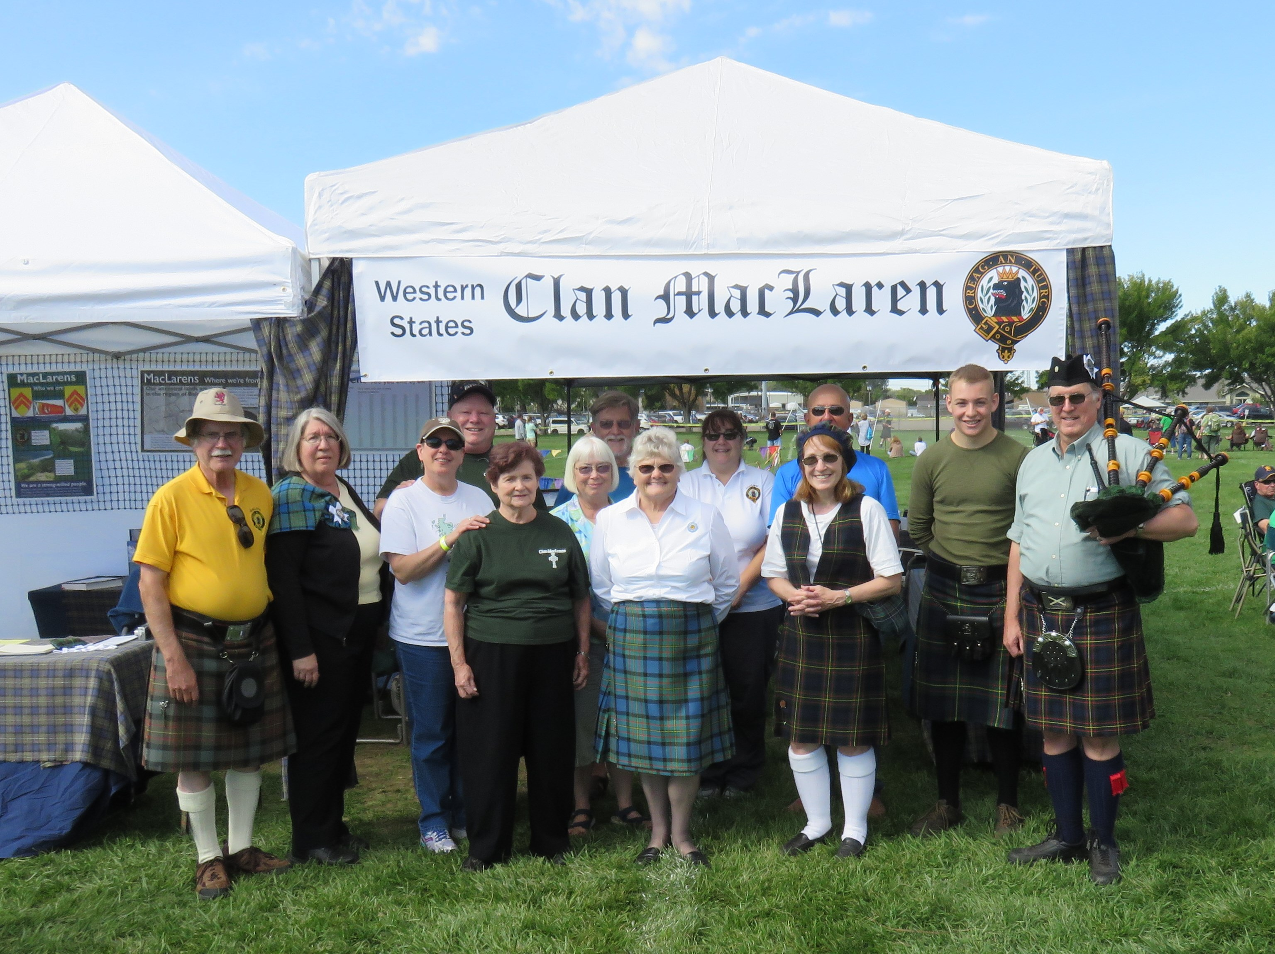
Gathering of WSCMS members at the Treasure Valley Celtic Society Highland Games in Boise, September 26, 2015 – Photo by Norm English

Message from the President – Nina Garcia
Welcome to all the wonderful founding members of Western States Clan MacLaren Society (WSCMS). After all the years of struggle with the CMSNA – we finally have our own ‘club’, and I appreciate the support from everyone in making the creation of WSCMS a reality.

Our aim is to have fun, foster the spirit of family and community, and focus on those issues that have meaning to those of us in the Western part of the United States and Canada.

2016 promises to be a fine year – new opportunities for us as a group and for each of you personally. We are still in the building stages, and I welcome any and all suggestions as to how we can make our society work best for all of us.

We are a family – related by DNA, by culture, by love of heritage and history, or simply things Scottish. So dear family, I wish you all the very best for 2016. Let’s have some fun.

Coming Events for 2016

January 16, 2016 Vancouver Island Scottish Country Dance Society Robert Burns Social – Victoria, BC
Info: www.viscds.ca
January 22, 2016 Calgary Burns Club 40th Anniversary Burns Supper – Calgary, AB
Info: www.calgaryburnsclub.com
Robert Burns Social – Edmonton, AB
Info: www.rscdsedmonton.com
January 30, 2016 5th Annual Robert Burns Supper – Shilo Inn – Newport, OR – 6:00 to 10:00 PM
February 20, 2016 Vancouver Island Scottish Country Dance Valentines Tea Dance – Victoria, BC
Info: www.viscds.ca
April 9, 2016 Oregon Scottish Festival – Linn County Fairgrounds, Albany, OR
April 23, 2016 ScotFest Spring Concert – Estes Park, CO Event Center
June 11-12, 2016 Newport Celtic Festival & Highland Games – Newport, OR
July 8-10, 2016 Athena Caledonian Games – Athena, OR

Observations From My Corner…
We’d like to provide a personal observation from one of the Society’s board members in each of our newsletter issues. Subsequent issues might also include observations from any one of our members, perhaps even you. Or, if you have an item of interest you’d like to share for a future issue, please send it to me at normengl@msn.com, keeping in mind the space limitations of the newsletter.

WSCMS Vice-President - Norm English
As the Vice-President and also Editor of this newsletter, I may be new on the scene to some of you. I initially became involved in Clan MacLaren back in 1986, when my wife Margaret, who had been a member of the North American Society for a couple of years, began as a convener at the Portland Highland Games while also being the Northwest Commissioner for that Society. As her involvement grew, it seems that mine did too.

We attended annual meetings for that Society in Woodland and Pleasanton, California, Portland, Victoria, Laurinburg, NC, Loon Mountain, NH, Estes Park, CO, and Alma, MI. At the same time, we continued
to convene games in places like Eugene, Albany, Newport, Athena, Oregon, and for many years in Portland. I

also was the Membership Secretary for the North American Society for 7 ½ years.

I now find myself being very excited about my involvement in this new organization from the ground up. I was privileged to attend the formation meeting of WSCMS in Boise this past September. Our Society will provide an opportunity for those of us living in the Western part of the United States and Canada to be a part of an organization through which we can enjoy our Scottish heritage and family association, unique to this part of North America. My nearly 30 years of involvement with MacLaren associations has been enlightening at times, and simply downright enjoyable most of the time, especially as I find out some of the historical events, happenings, and background of my Scottish ancestors, and also form friendships with some of my kin. As you become more involved too, I believe you will like what you see and experience.

Points of Interest
Many ‘Burns Night Suppers’ take place in January to celebrate Scotland’s finest poet, Robert Burns, who was born on January 25, 1759, to poor tenant farmers in Alloway, Ayrshire. Though his formal education ended at the age of 15, Burns began writing his first verses entitled, ‘My Handsome Nell’, and by the time he died in Dumfries on July 21, 1796, he had written more than 500 works, including the famous, ‘Tam O’Shanter’. Most Burns Suppers include the Selkirk Grace, haggis, a bit of Scottish humor, a wee dram or two, and the recitation of some of Burns’s poetic works. Take advantage of an opportunity to attend a Burns Supper in your area when you get the chance to do so.

A Wee Bit of Scottish Humor…
MacTavish visited London for his annual holiday and stayed at a large hotel. However, he didnae feel that the natives were friendly. ‘At 4 o’clock every morning’, he told a friend, ‘they hammered on my bedroom door, on the walls, even on the floor and ceiling. Och, sometimes they hammered so loud I could hardly hear myself playing the bagpipes.’

Looking Back…
In August, 1940, recently revealed secret letters tell of a plan to smuggle some 80 tons of gold bullion out of Scotland to a secret location in England, to keep it out of Nazi hands, should they carry out a planned invasion of the country. One letter states “The Regional Commissioner is providing 23 lorries for the transport.” “Please earmark a guard of one officer and 25 other ranks to act as escort”. The gold was to be picked up at the RBS branch in Glasgow’s Royal Exchange Square by volunteers from the Home Guard, due to a shortage of available regular soldiers. They were also to be sent 15 rifles, 10 Sten machine guns and 1,000 rounds of ammunition. The plan finally ended in October, 1944, as outlined in a memo that stated, “In view of the general relaxation of anti-invasion precautions, there is no further necessity for provision of the bullion escort for the Royal Bank of Scotland.” Story is from: www.scotsman.com/news

Membership Notes
At this past September’s meeting during which the WSCMS was formed, the Board voted to provide memberships at no cost for the calendar year 2016. In January, 2017, an annual mailing/dues notice will be sent to members of record at that time, and yearly dues of $10.00 will be requested in order for you to continue with your membership. We hope you enjoy this first year’s membership in the Society ‘on the house’, by celebrating your Scottish heritage, taking in a Scottish festival, games, or other event in your area, and participating in some direct way in one or more events. See a listing of just some of the events in our area elsewhere in this newsletter. We have lots to celebrate and enjoy.

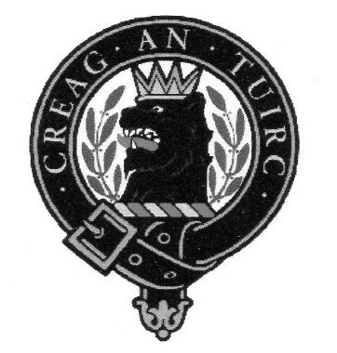

Western States Clan MacLaren Society, Inc.
2016-2017 Officers/Board Members

President Vice-President
Nina Garcia Norm English
nina.garcia349@gmail.com (503) 874-8101
normengl@msn.com

Secretary Treasurer
Karen Woodall To be determined
(360) 576-4969
starcars8@comcast.net

Board Members
Barbara Allen Gard Margaret English (971) 599-5759 (503) 874-8101
barbara.allen.gard@gmail.com mdeng59@live.com

Pete Woodall Tim McLaren
(360) 576-4969 (360) 546-2271
starcars8@comcast.net drtmclaren@msn.com

Western States Clan MacLaren Society, Inc.
WSCMS, Inc. is a duly registered non-stock, non-profit organization incorporated in 2015 under the laws of the State of Idaho

The Scottish Thistle is a quarterly publication expressly for the purpose of exchange and providing of information among WSCMS members

