Western States Clan MacLaren Society, Inc.
A non-stock, non-profit organization incorporated under the laws of the
State of Idaho
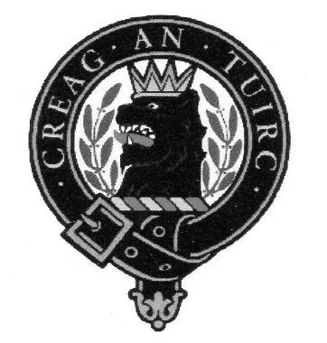
WSCMS, Inc. Annual Dues – 2022

Dear WSCMS Member:

This letter is to advise you that your annual WSCMS dues are due/payable effective January 2022.

We sincerely hope that you will continue your membership in WSCMS; our organization continues to foster and encourage interest in the history, culture, and traditions of Scotland in general and Clan MacLaren in particular.

Annual dues are $10.00 per member for the period January 1, 2022/December 31, 2022. Checks can be made payable to WSCMS, Inc. and should be sent to the Membership Secretary at the address noted below. Please send a copy of this completed form with your payment.

Provide your current contact information. It has been a couple of years since our membership records have been verified as up to date. If you are paying for more than yourself, please provide names and contact information for the others, on the back side.

Name_____________________________, Email________________________________

Phone No.______________________, USPS Address_________________________________

Thank you.
Creag An Tuirc

Tim McLaren
Membership Secretary
11314 NE 36th Ave.
Vancouver, WA 98686
WSCMS Revised 2 February, 2022

